Floyd D. Archer
February 19, 1896 – April 15, 1901

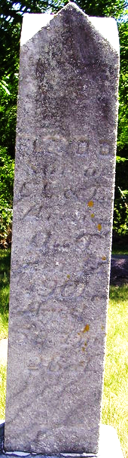
Photo by Deb Curry

The funeral of the five-year-old son of Elmer Archer occurred at the M. E. Church Wednesday morning, conducted by Rev. Peters. Interment in Pleasant Mills Cemetery.

Decatur Democrat; Adams County, Indiana
Thursday, April 18, 1901
**
Indiana, U.S., Death Certificates, 1899-2017
Name Floyd Archer
Gender Male
Race White
Marital Status Single
Age 5 years, 0 months, 0 days
Birth Date abt 1896
Birth Place Adams Co., St Marys Tp
Death Date 15 Apr 1901
Death Place Washington, Adams, Indiana, USA
Death Registration Date 1901
Father Elmer E Archer
Mother Eilis Ann Roe
Informant D. J. Winans; Pleasant Mills, Indiana
Burial April 17, 1901; Pleasant Mills
**
Indiana Deaths, 1882-1920
Name: Floyd Archer; Date: 15 Apr 1901; Location: Washington Township; Age: 5 yr; Gender: Male; Race: White
Source Location: County Health Office, Decatur
Source Notes: The source of this record is the book H-22 on page 7 within the series produced by the Indiana Works Progress Administration.

