Elmer E. Archer
May 24, 1865 – December 17, 1943

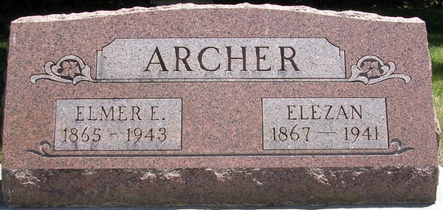
Photo by PLS

Funeral services for Elmer E. Archer, 79, of 3807 Barr Street who died Friday morning at 4:20 o'clock of a heart ailment at St. Joseph's Hospital following a three-weeks illness, will be held Monday afternoon at 1 o'clock at D. O. McComb & Sons Funeral Home and 2 o'clock at the First Methodist Church at Decatur. Burial will be in the Pleasant Mills Cemetery near Decatur. Friends may call at the funeral home after this noon.
Surviving are four sons, Dwight, Oscar and Floran, all of Fort Wayne and Lloyd of Columbia City; three grandchildren, a great-grandchild, and a sister, Mrs. Mabel Winans of Pleasant Mills.

Journal Gazette, Allen County, Indiana
Saturday, December 18, 1943

**
Indiana, Death Certificates, 1899-2011

Name: Elmer E Archer
Gender: Female
Race: White
Age: 78y, 4m, 23d
Marital status: Widowed
Birth Date: 24 May 1865
Birth Place: Decatur-Adams-Ind
Death Date: 17 Dec 1943
Death Place: Ft Wayne, Allen, Indiana, USA
Mother: Susanne Harrison
Spouse: Elezan Archer
Informant: Dwight Archer, Ft. Wayne
Burial: 12-20-1943, Pleasant Mills, Ind.

