Elezan Catherine (Roe) Archer
September 17, 1867 – June 5, 1941

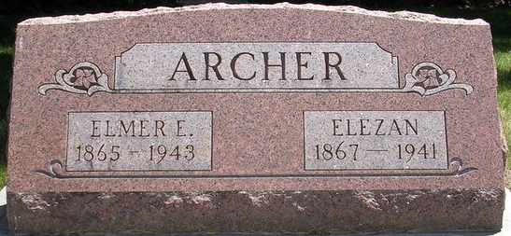
Photo by PLS

Mrs. Elezan Catherine Archer, 73, 515 Wallace Street, died of a cerebral hemorrhage at 6:55 o'clock Thursday evening at the Methodist Hospital, following an extended illness. She was a member of the First Methodist Church at Decatur and the Royal Neighbor Lodge.
Survivors include the husband, Elmer E. Archer; four sons, Dwight M., I. W. and Floren C. Archer of this city and L. B. Archer of Columbia City; four grandchildren; one greatgrandchild; three sisters, Mrs. Linnie E_(e?)nsterling of Jonesville, Mich., Mrs. Rose Munson of Antwerp, O., and Mrs. Anna Smith of Decatur, and two brothers, William and Edward Roe of Decatur.
The body was removed to D. O. McComb & Sons Funeral Home, where it may be viewed after noon today.

Journal Gazette, Allen County, Indiana
Friday, June 6, 1941

**
Indiana, Death Certificates, 1899-2011

Name: Elezan Catherine Archer
[Elezan Catherine Roe]
Gender: Female
Race: White
Age: 72y, 8m, 18d
Marital status: Married
Birth Date: 17 Sep 1868
Birth Place: Adams Co, Indiana
Death Date: 5 Jun 1941
Death Place: Ft Wayne, Allen, Indiana, USA
Father: Isaac Roe
Mother: Catherine Smith
Spouse: Elmer E Archer
Informant: Dwight M. Archer
Burial: 6-8-1941, Pleasant Mills Cemetery

