Eddie Archer
December 12, 1871 – December 15, 1871

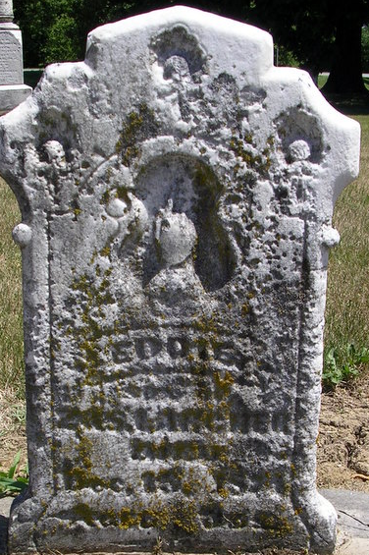
Photo by Deb Curry

Eddie Archer from tree Brock Family Tree
Birth 12 Dec 1871 Adams, Indiana, USA
Death 15 Dec 1871 Adams, Indiana, USA
Father Zachariah Archer (1840-1878)
Mother Nancy J. Braddock (1840-1872)
23517 People 1 Record 3 Sources

