Aaron Archer
August 10, 1810 – May 20, 1881

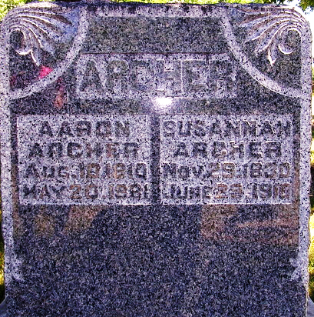
Photo by Deb Curry

Aaron Archer from tree Pollock-Barnhart-Friel-Briggs Family Tree
Birth 10 Aug 1810 Chesterfield, Chesterfield, Virginia, USA
Marriage 17 Jan 1850 Adams, Indiana, USA
Residence 1880 Adams, Indiana, USA
Death 20 May 1881 Adams, Indiana, USA
Father Aaron Archer (1781-1871)
Mother Margaret Heath (1785-1856)
Spouse Susannah Harrison (1830-1910)

