Adam Alonzo Alguire
October 23, 1849 – August 8, 1920

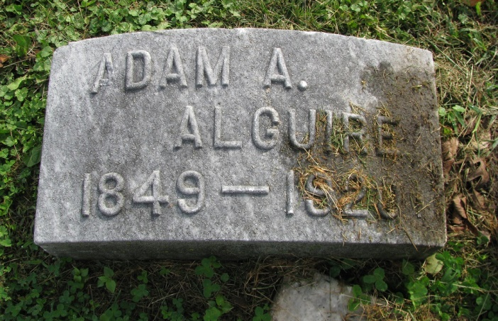
Photo by PLS

Collection: Ohio Deaths 1908-1953

Name: Adam Alonzo Alguire
Death date: 06 Aug 1920
Death place: Delphos, Allen, Ohio
Birth date: 23 Oct 1849;
Birth place: Ohio
Age at death: 70 years 9 months 13 days
Gender: Male
Marital status: Married
Race or color: Caucasian
Occupation: Laborer farm
Residence: Delphos, Allen, Ohio
Burial date: 08 Aug 1920
Cemetery name: Pleasant Mills Indiana Cemetery
Spouse name: Elizabeth Brown
Father name: Jacob Alguire b. Pennsylvania
Mother name: Margret Miller b. Pennsylvania
Informant: Elizabeth Alguire of Delphos, Ohio
GSU film number: 1991304; Digital GS number: 4020541; Image number: 1657; Reference number: fn 51380

