Olin Randolph Acker
June 5, 1891 – December 20, 1893

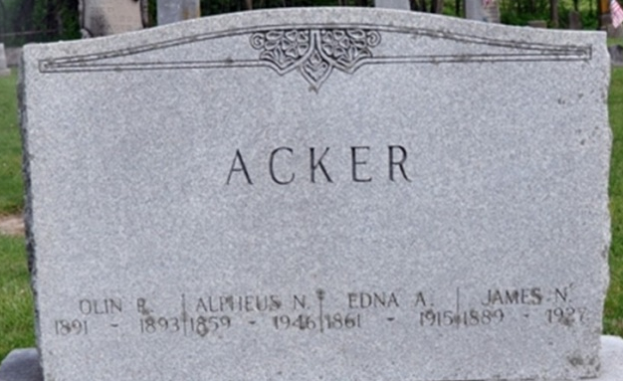
Photo by Deb Curry

Adams Co, IN WPA Birth Index

Acker, --- Alpheus & Edna Foust M W June 5 1892 H-3 6

**
Olan Randolph Acker from tree Roop_File_2023-02-23
Birth 5 Jun 1892 Allen, Indiana, USA
Death 20 Dec 1893 Allen, Indiana, USA
Father Alpheus Norman Acker (1859-1946)
Mother Edna Adelia Faust (1861-1915)

