Eva Marjorie (Death) Yerrick
September 2, 1900 – January 9, 1981

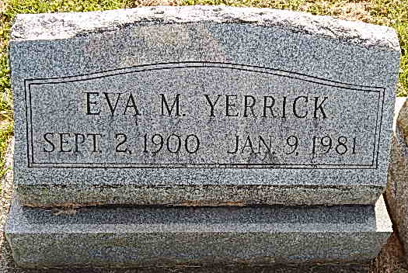
Photo by Alicia Kneuss

Services are 1:30 pm Monday in Winteregg-Linn-Haggard Funeral Home, Decatur, for Eva M. Yerrick, 80, of 2517 Sherman Blvd. She died at 10:30 pm Friday in Parkview Memorial Hospital.
Mrs. Yerrick, a native of Adams County, is survived by two stepsons, Robert V. of Fort Wayne and Edward P. of Satsuma, Fla.; one sister, Ada Everett of Decatur and one brother, Jack Death, also of Decatur.
Friends may call from 2 to 4 and 7 to 9 pm today at the funeral home. Burial will be in Mount Tabor Cemetery.

Journal-Gazette, Allen County, Indiana
January 11, 1981

