Helen M. (Brown) Williamson
May 15, 1920 – September 1, 1971

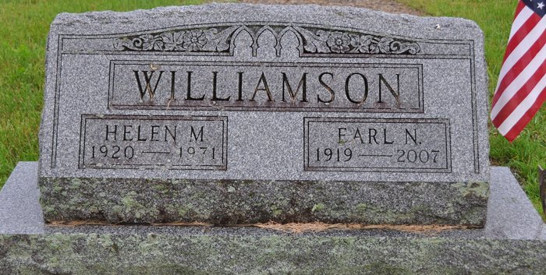
Photo by Deb Curry

Pleasant Mills – Wife of Earl (Dutch) Williamson, Ms. Helen M. Williamson, 51, died at her home Wednesday night.
Three sons, one daughter, one sister, two brothers, also survive.
Services at 3:30 pm Saturday at Zwick Funeral Home in Decatur.

Journal-Gazette, Allen County, Indiana
September 3, 1971, Page 11A
*****

Indiana, Death Certificates, 1899-2011

Name: Helen May Williamson
[Helen May Brown]
Gender: Female
Race: White
Age: 51
Marital status: Married
Birth Date: 15 May 1920
Birth Place: Indiana
Death Date: 1 Sep 1971
Death Place: Pleasant Mills, Adams, Indiana, USA
Father: Elliott E Brown
Mother: Myrtle Chronister
Spouse: Earl Williamson, informant
Burial: Sept. 4, 1971; Mt. Tabor Cemetery

