Tempy Ann (Acker) Shaffer
June 15, 1826 – April 27, 1892

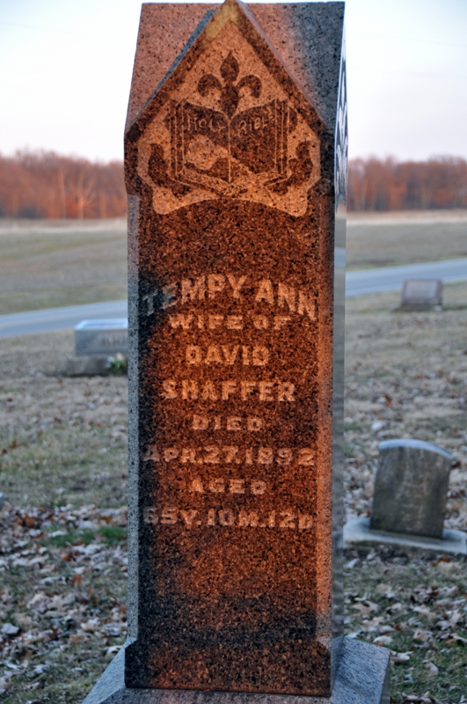
Photo by Deb Curry

Tempy Ann, wife of David Shaffer, of St. Mary's township, died last Wednesday morning about eight o'clock. She was among the oldest settlers of this county.

Decatur Daily Democrat, Adams County, Indiana; Friday, April 29, 1892

Contributed by Karin King

