Reason Shaffer
January 20, 1860 – June 10, 1920
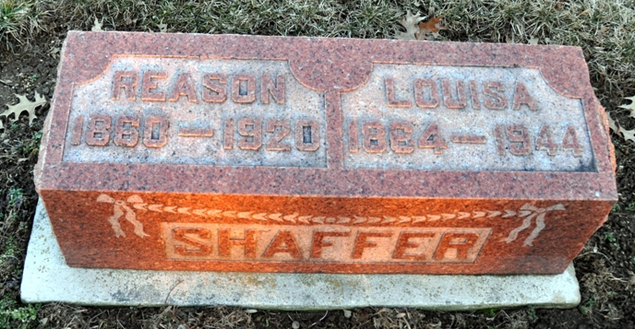
Photo by Deb Curry

HEART TROUBLE
Causes Death of Reason Shaffer of St. Mary’s Township Early Today
WAS SIXTY YEARS OLD
Had Been Assisting in the Care of Sick at Home of Neighbor All Night

Going to his home early this morning after he had been up all night assisting in the care of the sick at the home of a neighbor, Reason Shaffer, well known resident of St. Mary’s township, succumbed at 5:15 o’clock this morning, following an attack of heart trouble.
During the night Mr. Shaffer had complined of not feeling well and going to his home he took some medicine for relief, and shortly afterward his condition became serious, and before a physician could reach his home he had expired. Death was pronounced as probably due to heart trouble, and Coroner Clark was summoned, as death had come before the arrival of the family physician, although he had been given treatment by the physician for some time. The coroner confirmed the statement of the family doctor, that death was due to heart trouble.
Reason Shaffer was born in St. Mary’s township January 20, 1860, and had lived there all his life. He was one of the best known farmers of the township, and had many friends over the county. He was a son of David and Tempyann Acker Shaffer, and was sixty years old last January 20. Surviving besides the widow are one daughter, Mrs. Warren Hamrick, of Fort Wayne, and a young man whom they had reared as their son, Minor H. Cogswell, who is now in the United States army, and located at Camp Dix, N. J. There are also two grandchildren, Oliver R. and Harry B. McColloch, children of Mrs. Hamrick by a former marriage. Two brothers and three sisters are also living, they being Almond and Levi Shaffer, of Bobo; Mrs. Henry Ehresman, Mrs. Lavina Heath, Bobo, and Mrs. Wilson Smith, of Columbus, O. Funeral services will be held Sunday afternoon from the Methodist church at Pleasant Mills at 2:30 o’clock, the pastor of the church officiating.

Unknown newspaper clipping

