John Anthony Geimer
January 10, 1948 – May 6, 1971

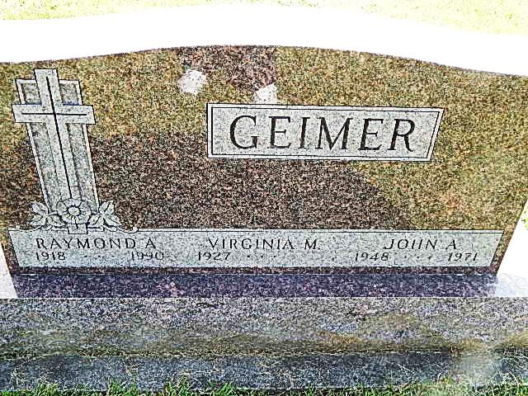
Photo by Alicia Kneuss

Funeral services for John Anthony Geimer, 23, of Pleasant Mills, a veteran of the Vietnam war, will be conducted Monday afternoon at 2 p.m. at the Winteregg-Linn funeral home, with Rev. Gerald Gerig officiating. Burial will be in the Mt. Tabor cemetery. Friends may call after 7 p.m. today.
Mr. Geimer was killed Thursday evening in a one-car accident in Jackson, Georgia.
The accident victim was a member of the First Missionary church of Berne.
He was born in Decatur on January 10, 1948, the son of Raymond a. and Virginia M. Archer-Geimer.
He was a flight instructor for the Airline Aviation Academy at Griffin, Ga.
Over 1,000 Combat Hours
Mr. Geimer, who was released from activity duty on April 1, 1971, graduated from Adams Central high school in 1966. He enlisted in July of 1968 and served one tour of duty in Vietnam. He was with the American division, Chu Lai, Vietnam, and was a Chinook helicopter pilot and flew more than 1,000 combat hours.
Surviving are his parents; one sister, Miss Sarah S. Geimer, a student at Indiana University, and the grandparents, Mr. and Mrs. Fred Geimer, route 4, and Mrs. Sherman (Maude) Archer, Pleasant Mills. (May 8, 1971)

Adams County Library, Decatur (IN)
Obit Book F, image 52
Transcribed by Janice Vasilovski

