Betreva M (Biberstine) Everett
May 24, 1924 – September 29, 2016
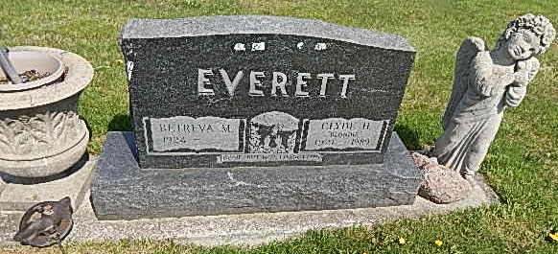
Photo by Alicia Kneuss

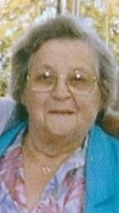
Betreva M. Everett, 92, of Decatur, IN passed away Thursday, September 29, 2016 at Adams Woodcrest. Betreva was born on May 24, 1924 in Linn Grove to the late Michael and Martha (Neuenschwander) Biberstine. She married Clyde H. Everett; he preceded her in death in 1989.
Betreva was a member of Pleasant Mills Baptist Church and was a homemaker.
She is survived by two daughters, Susan Burger and Theresa Everett both of Decatur; 15 grandchildren. She was preceded in death by three sons, Eugene, James and Clyde Everett; a son-in-law Steven Burger; a granddaughter, Heather Everett and a great grandson, Hunter Dean.
Funeral Service will be held at 11:00 a.m. Monday, October 3, 2016 at Haggard-Sefton & Hirschy Funeral with calling prior from 9:00 – 11:00 a.m.
Burial will take place in Mt. Tabor Cemetery.
Memorials are to PAWS of Adams County.

Haggard-Sefton & Hirschy Funeral Home online obit (accessed 10/24/2016)

