Dale Death
March 12, 1912 – March 13, 1974

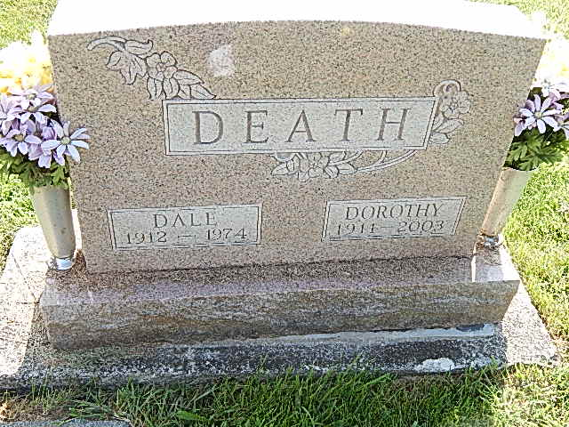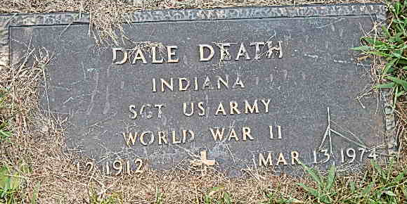
Photos by Alicia Kneuss

Dale Death, 62, dies at Dephos
Dale Death, 62, of Delphos, O.; a former Decatur city policeman, died at 2:45 p.m. Wednesday at this home, following an extended illness. Mr. Death, who was employed at the Ford Motor Co. in Lima, O., was a veteran of World War II, and a member of the American Legion, VFW, Moose, Elks and the Fraternal Order of Police. He had resided in Delphos eight years.
Born in Decatur on March 12, 1912, he was a son of Clifford and Lettie May Kirkland-Death, and was married on August 27, 1965, to Dorothy Johnson, who survives.
Also surviving are three step-children, Don Johnson, Mrs. Harold (Carolyn) Bolton, and Mrs. Robert (Dorothy) Stemen, all of Van Wert, O.; 3 sisters, Mrs. James (Ada) Everett of Pleasant Mills, Mrs. Eva Yarrick and Mrs. Orpha James, both of Fort Wayne; one brother, Jack Death of route 3, Decatur; and seven step-grandchildren. Five brothers preceded him in death.
Funeral services will be held at 10 a.m. Saturday at the Winteregg-Linn and Haggard Funeral Home, with Rev. Russell L. Wagner officiating. Burial will be in the Mt. Tabor Cemetery. Friends may call at the funeral home after 3:30 p.m. Friday. Military graveside rites will be conducted by the American Legion. Preferred memorials are to the Cancer fund.

Decatur Daily Democrat, Adams County, Indiana
Thursday, March 14, 1974

