Joseph Franklin Kortenber
December 21, 1890 – February 12, 1948

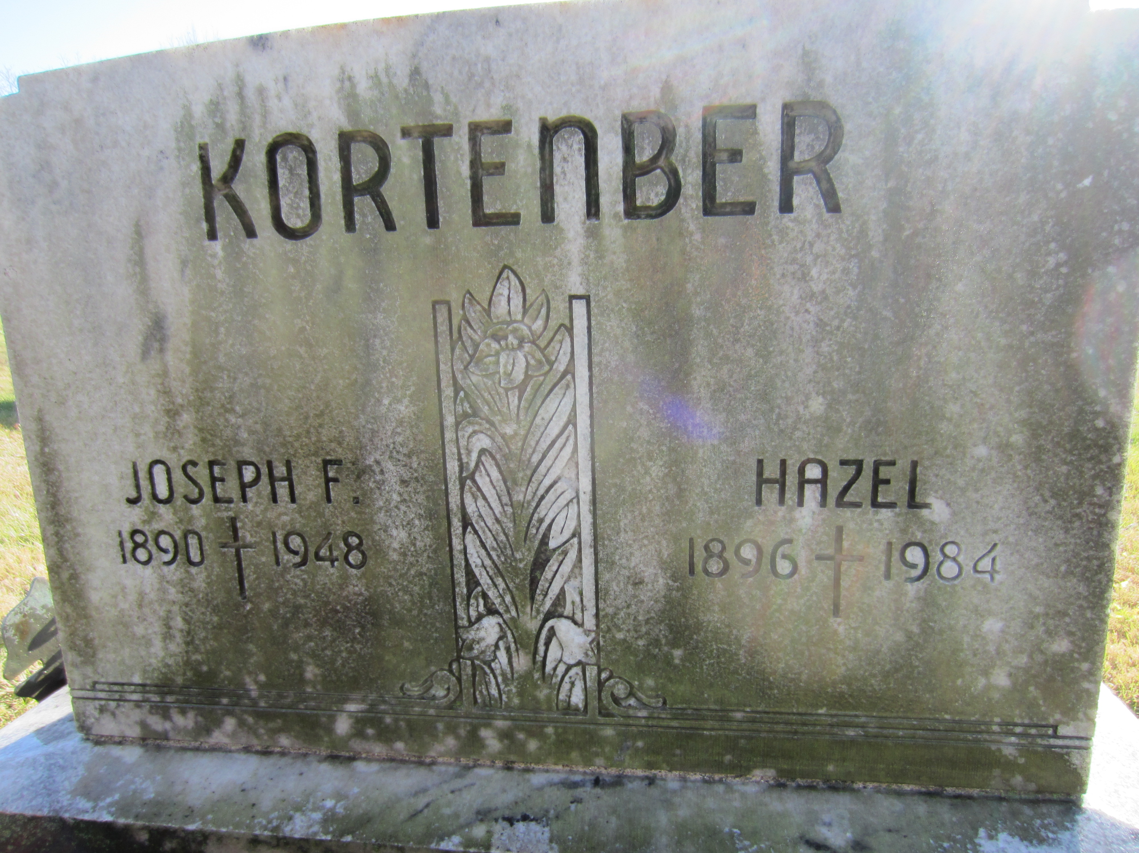
Photo by Laura Evans Steele

Indiana, Death Certificates, 1899-2011

Name: Joseph F Kortenber
Gender: Male
Race: White
Age: 57y, 1m 21d
Occupation: fireman
Marital status: Married
Birth Date: 21 Dec 1890
Birth Place: Decatur Ind
Death Date: 12 Feb 1948
Death Place: Decatur, Adams, Indiana, USA
Father: Herman Kortenber
Mother: Mary Hackman
Spouse: Hazel Kortenber, age 54
Informant: Mrs. Joe Kortenber, Decatur, Ind.
Burial: 2-14-1948 St. Joseph
*****

Bio of Joseph Franklin Kortenber
by Laura Evans Steele

Joseph Franklin Kortenber was the son of Herman and Mary (Hackman) Kortenber. He was born Dec. 21 1890 in Adams County, Decatur IN. He was one of eight children, 4 sisters and 3 other brothers.
Joseph married Hazel Leora Tumbleson on Jan. 24, 1924 in Decatur, IN. They had 7 children, 3 boys and 4 girls.
He was the first full-time fireman for the Decatur Fire Department. He and the Decatur mayor went up to Detroit to bring back the town’s first fire truck. On the night of Feb. 11, 1947 they made a run to a house fire. It was a bitterly cold night and the hoses kept freezing and the fire was blazing hot and Joe got caught between the two. The doctor said his heart couldn't stand the strain of the temperature extremes. He died at his home on John Street of a heart attack the next day.

