Terry Lee Williams
April 23, 1955 – June 21, 1955

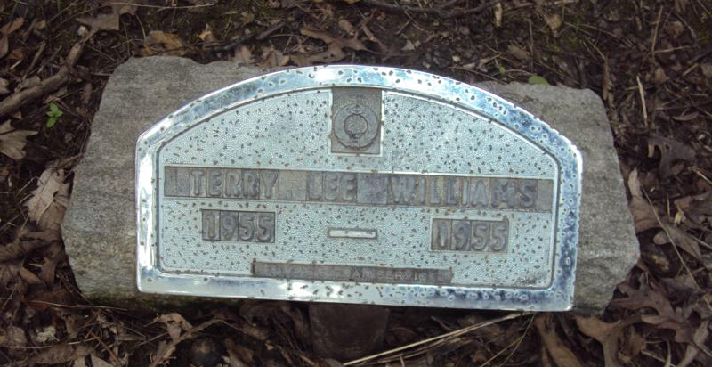

Terry Lee Williams Dies Last Evening

Terry Lee Williams, infant son of Mr. and Mrs. Clarence Williams of Decatur route 6, died at 8 o'clock Tuesday night of the Adams county memorial hospital. Death was attributed to complications. The child was born April 23 of this year, and was a member of the Pleasant Mills Methodist church. Surviving are the parents; three brothers, Fred, James and William, and two sisters, Barbara and Susette, all at home, and the grandfathers, Albert Williams and Greely Troutner, both of near Decatur. Services will be held at 10 a.m. Friday at the Gillig and Doan funeral home the Rev. Harley Davis officiating. Burial will be in the Reynolds cemetery north of Decatur. Friends may call at the funeral home after 7 o'clock this evening.

Nola Rains Note: Son of Clarence & Isabelle (Troutner) Williams.

Reynolds Cemetery Book by Nola Rains
Decatur Daily Democrat, Adams County, Indiana
22 Jun 1955, vol. LIII, #146

