Margaret (Baker) Spangler
January 1, 1885 – June 29, 1891

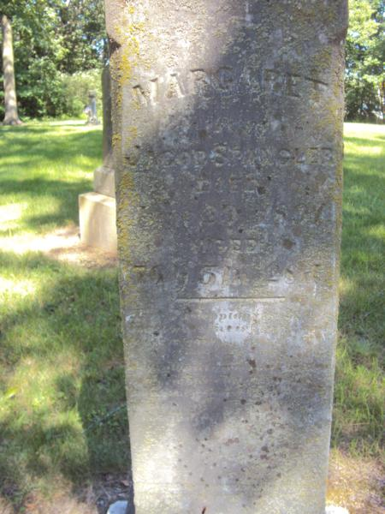

Margaret Spangler

Mrs. Jacob Spangler, of Preble township, died Monday evening and was buried Wednesday. The funeral services were conducted by Rev. Hofferbut at the Evangelical church.

Nola Rains NOTE: Spanger, Margaret; 1 Jan 1835 - 26 June 1891; 56y 5m 28d; Wife of Jacob Spangler; Dau. of Theobald & Margaret Baker - born in Bavaria, Germany

Reynolds Cemetery book by Nola Rains
Decatur Democrat, Adams County, Indiana
July 3, 1891

