Jacob E. Spangler
December 12, 1834 – May 15, 1921

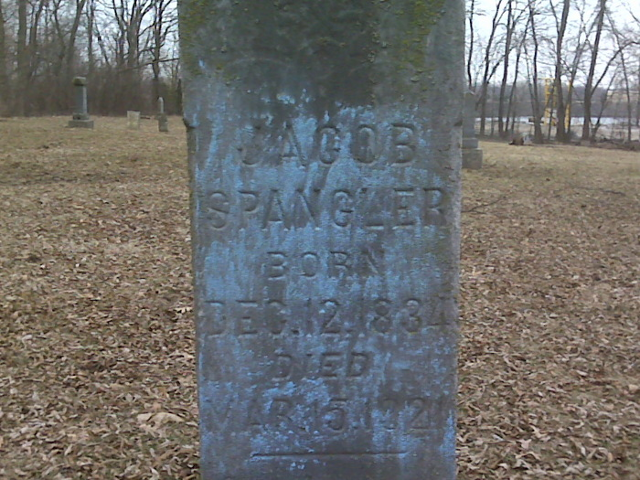
Photo by Lee Sheets

AT NOON TODAY
Occurred Death of Jacob Spanger, Well Known Decatur Citizen
Ill of Pneumonia - The Past Three Months
Funeral Thursday at the Evangelical Church

Jacob Spangler, well known resident of North Eighth street died at 11:45 o'clock today at the home of his son-in-law, Jacob Henschen, in Kirkland township, following a three months' illness from pneumonia.
He was born in Kirkland township December 12, 1834, and had been a resident of the county all his life. The wife died some time ago. Surviving are two daughters, Miss Eliza Spangler, who made her home with her father on Eighth street, and Mrs. Jacob Henschen, in Kirkland township, at whose home he passed away; Rev. D. D. Spangler, of Kendallville, and Rev. C. W. Spangler, of Peru.
Funeral services will be held Thursday afternoon at the Decatur Evangelical church, at 1:30 o'clock, the Rev. Haney officiating. Burial will be at the Reynolds cemetery, north of the city.

Nola Rains Note: cemetery listing d. 16 March 1921

Unknown newspaper clipping
Reynolds Cemetery book by Nola Rains

