Ezra Lister
January 19, 1825 – January 9, 1901

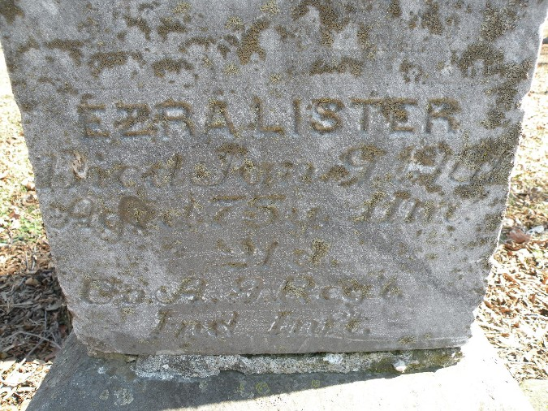
Photo by Tera Butler

The condition of Ezra Lister grows worse with each hour and his end is said to be but a few days away at farthest. He was taken much worse the latter part of last week and sank gradually until yesterday, when he lost consciousness for the first time. For over a year he has been suffering with lung trouble but has clung to life with a tenacity rarely found in one of his years. During last winter he was reported dying several times but rallied each time and was able during the past fall and summer to be down street nearly every day, and say a word now and then for the principals of democracy and for which he has been an ernest advocate for so long. Brother veterans of the G.A.R. have been caring for him during his late illness and rendering such aid as was in their power.
He has been one of the best citizens of old Adams county where he has resided more than three score years and ten and his presence will be sorely missed by many. He is seventy-six years of age.

Unknown newspaper clipping
*****

Shortly after ten o'clock on Wednesday evening of last week came the death of Ezra Lister at his home on North Third street. He had been very low for two weeks past and for a day or so had been unconscious. The end came with scarcely a struggle and after months of suffering he calmly slept away. Mr. Lister was the oldest settler of the county, having immigrated here in 1828, and for nearly three-quarters of a century had been a citizen of Adams county almost continuously. He was of sturdy character and had scarcely known what it meant to be sick until about a year ago when he contracted a severe cold, which finally settled on the lungs and resulted in consumption. Even after having a number of hemorrhages and when one lung was entirely wasted he lived a year. Uncle Ezra was a great fisherman and hunter, and many an interesting story could be related of the days when deer were plentiful in the woods. Even during his latter days he captained many a crowd to lakes and forests at a distance and enjoyed the sport as much as men fifty years his junior.
Ezra Lister was born in Ross county, Ohio, January 15, 1825 and died January 9, 1901, lacking but six days of being seventy-six years old. His education as that of all pioneers was very limited but his knowledge was increased by contact with all classes of people and he was considered a sharp trader and a keen business man. He was actively engaged in farming until a few years ago when he retired and moved to this city. During his life time he has married four times, the last surviving him with their only son, Thomas Tilden. Another child, Mrs. John Woods, of Logansport also remains, two having preceded the father. In politics Mr. Lister was a democrat and the party has always been strengthened by his labor of those principals. He was not an office seeker nor a politition but never failed to express his views in a way to do great good. He was an old veteran and the funeral services which were held from the house at ten o'clock Friday morning were in charge of the G.A.R., Rev. H. C. Duckett
officiating.

Nola Rains Note: Lister, Ezra; 19 Jan. 1825 - 9 Jan. 1901, 75y 11m 21d, Co. A. Ind. Inf. (Civil War), son of Joshua & Lydia Lister.

Unknown newspaper clipping
Reynolds Cemetery Book by Nola Rains
Handwritten date of Jan. 9, 1901
*****
Biography

EZRA LISTER, of Washington Township, is one of the oldest living pioneers of Adams County. He was born in Ross County, Ohio, January 15, 1825, son of Joshua and Lydia Lister, natives of Maryland. The father's ancestors were of German origin and the mother's of Irish. In 1828 the family immigrated to Adams County, settling two and a half miles north of Decatur, where they lived until 1830, then removed to Carroll County, Indiana, where the father died in September, 1831. One year later the family returned to Adams County, where our subject was reared to the scenes of pioneer life. The county at that time contained but few families. He received a rudimentary education in the early pioneer schools, and has been a life-long farmer, enduring all the trials, hardships and privations of the early pioneer. He was married December 21, 1848, to Eliza J. Ball, a native of Indiana, and they had three children - Sarah F., wife of James M. Patterson, of Logansport, Indiana; Rachel S., wife of John Woods, also of Logansport. One child is deceased. Mr. Lister has been four times married. His present wife has one son, Thomas T. He has been a resident of Washington Township for many years, is a Democrat in politics, and an honest, representative pioneer.

Biographical and Historical Record - Adams and Wells Co. Indiana Lewis Publishing Co. Chicago, IL 1887

