Esther Lambert
About 1890 – February 5, 1905

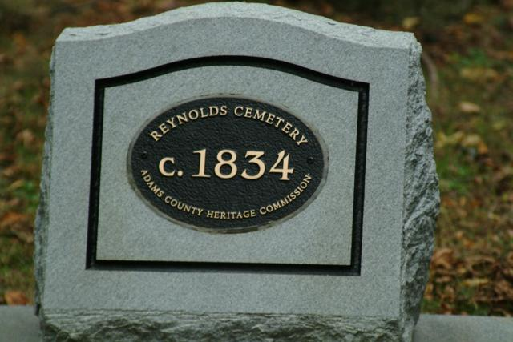
Information from Karin King

Indiana, Death Certificates, 1899-2011
Name: Ester Lambers
Gender: Female
Race: White
Age: 15
Birth Date: abt 1890
Birth Place: County Infirmary, Adams Co Ind
Death Date: Feb 5, 1905
Death Place: Washington, Adams, Indiana , USA
Father: John Lambers
Mother: Anna Carpenter
Informant: Jacob Graber; Decatur, Ind.
Burial: Feb. 7, 1905; Co. Infirmary

Esther was originally buried at the County Home, but was moved to Reynolds according to DAR Cemetery Records (red) at the Heritage Room, Berne Library

