Sadie E. (Jenks) Krick
May 12, 1879 – December 12, 1949

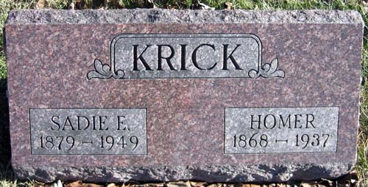
Photo by Greg Michell

MRS. SADIE KRICK
Rites Thursday for Mrs. Sadie Krick

Mrs. Sadie Krick, 71, died at 10:30 p.m. Monday at her home, 1152 Glasgow Avenue, after a long illness. She was a member of the St. Paul's Methodist Church. Surviving are a half-sister, Mrs. Perry Mason, Bluffton; a half-brother, Lafe Swygart, Decatur, and several nieces and nephews. The body was taken to the Jule Schone Funeral Home. Services will be held at 2 p.m. Thursday.

Fort Wayne Journal Gazette, Allen Co, IN; Wednesday, 14 December 1949, p. 18

