Samuel Dutcher
February 2, 1812 – March 25, 1899

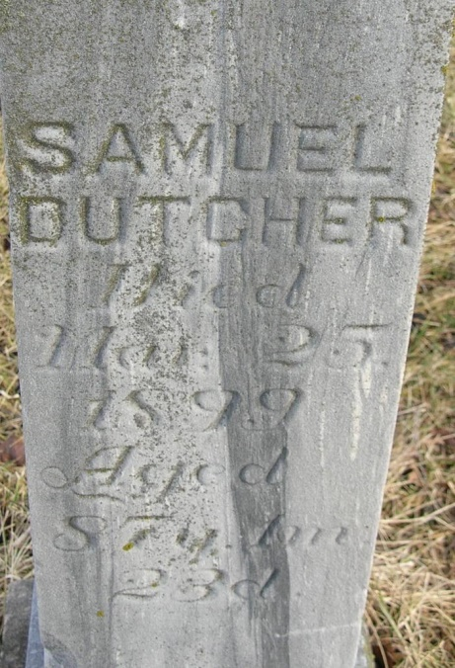
Photo by JC

Samuel Dutcher was born in Ontario county, New York, February 2, 1812, departed this life March 25, 1899, aged eighty-seven years, one month and twenty-three days. At the age of twelve years the deceased moved to Wyandotte county, Ohio, where he remained until 1849, when he with his family came to this state where he resided until his death. He was united in marriage to Catharine Dridleson in 1832, to this union were born twelve children, seven sons and five daughters, five children and his wife having preceeded him to the promised land. Seven children remaining to mourn the loss of a kind and loving father. He and his wife united with the Concord Evangelical Lutheran church in 1860, of which he was a faithful and consistant member until the time of his death. In the death of father Dutcher, Adams county looses (sic) another of her pioneers. He having resided here nearly fifty years. After having served his generation well by the will of God, he fell asleep to awake in the newness of life on the other shore where those aged bedimmed eyes shall with bee those who have gone before, and behold the beauties which the Lord has in store for those who love and serve him. Funeral services were conducted Monday by Rev. Fryburger of Monroeville, interment in Monmouth cemetery.

Hand dated March 30, 1899

Monmouth Cemetery – A Record of All Known Burials in the Monmouth Cemetery, compiled by Nola Rains, 2002.

