Andrew Norby Sr.
January 19, 1940 – December 10, 2017
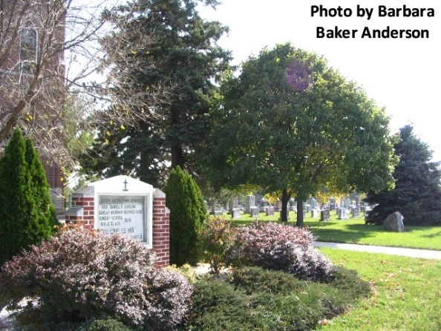
Andrew Norby Sr., 77, of Decatur, Indiana passed away Sunday, December 10, 2017 at Lutheran Hospital in Fort Wayne. His death was unexpected.
He was born on Friday, January 19, 1940 in Audubon County, Iowa the son of the late Carl Norby and the late Rosella (Struble) Norby. He married Barbara Walters on March 17, 1968 in Winterhaven, California.
Andy was a veteran of the United States Navy, serving during the Vietnam War and being honorably discharged at the rank of MM1 (Machinist Mate 1st Class). He worked at Dolco Packaging in Decatur, retiring in 2002 following 35 years of service. Following his retirement, Andy worked at the Cross Creek Golf Club in Decatur where he remained active until his death. Andy was active in different areas of interest including bowling, Decatur Little League, and golf.
He was a member of Zion Lutheran Church in Decatur where he was involved in the Parent Teacher Association while his boys were in school. He was also a member of American Legion Post #43 of Decatur.
Survivors include his wife, Barb Norby of Decatur; four sons, Andrew (Melissa) Norby Jr, James (Tammy) Norby, & Richy Norby all of Decatur & Larry (Bob Fox) Norby of LaPorte, IN; two sisters, Joann (Al) Kring of LaPorte, IN & Rosy (Bob) Steele of Danville, CA; brother, Jim Norby of Tuscon, AZ; & three grandchildren, Allyson Norby, Alexyss Norby, & Ryne Norby.
He was preceded in death by a sister, Brenda Cole and a brother, Carl Norby.
Funeral services will be held at 1:00 p.m. Friday, December 15, 2017 at Zion Lutheran Church in Decatur with Pastor James Voorman officiating. Friends will be received from 4 to 8 p.m., Thursday, December 14 at Zwick & Jahn Funeral Home in Decatur and one hour prior to the service at the church on Friday.
Preferred memorials are to Zion Lutheran School Athletic Department.

Zwick & Jahn Funeral Home online obit (accessed 12/11/2017)

