Hannah Koenemann
1878 – June 3, 1940

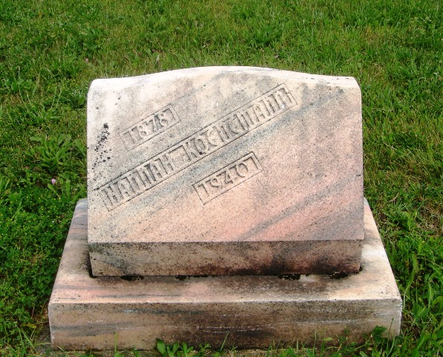
Photo by HoosierGirl88
KOENEMAN
Miss Hannah Koeneman, 62, died at 3:15 o’clock Monday morning at the home of her brother, Arthur Koeneman of R.R. No. 1, Decatur.
Survivors include a sister, Mrs. Sophia Macke of Root Township, and five brothers, Herman and Arthur of Preble Township; Henry of this city; William of Hoagland and Ernest Koeneman of New Haven; 13 nephews and nieces.
She was a member of the Friedheim Lutheran Church and the Tabea Society.
Journal-Gazette, Fort Wayne, IN; Tuesday, June 4, 1940
Contributed by Jim Cox

