Louise (Betz) Kiess
December 13, 1829 – February 15, 1902

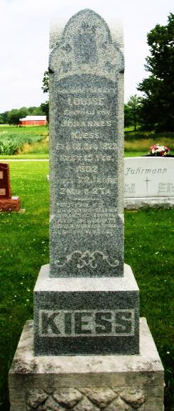
Photo by HoosierGirl88

AN AGED LADY DEAD
Mrs. Louisa Kiess, who lived two miles northeast of Preble, died at her home Saturday morning at 7 o'clock from old age. She leaves eight children - four sons and four daughters. The daughters are Mesdames Joseph Mann and John Bieberick, of Preble township, and Charles Doehrman and Joseph Koby of Fort Wayne. The sons are John, Charles, Frank and Joseph. The funeral was held Tuesday at 1 o'clock, sun time, at the Friedheim church.

Fort Wayne Weekly Sentinel, Allen County, Indiana; Wednesday, Feb. 19, 1902

Contributed by Karin King

