Donald E. Gehres
February 19, 1944 – June 28, 2017
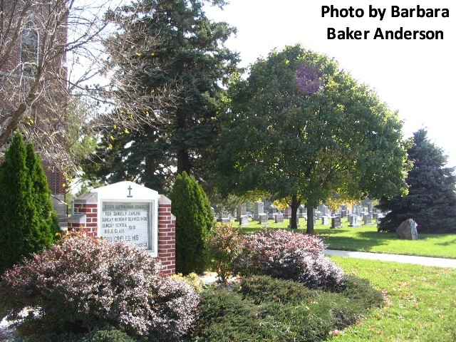
Donald E. Gehres, 73 years old of Decatur, Indiana, passed away on Wednesday, June 28, 2017at his residence following a brief illness.
He was born on Saturday, February 19, 1944 in Columbus, Ohio the son of the late Doyle F. Gehres and the late Winona A. (Gehres) Gehres. He married Shirley Scheumann on September 17, 1965 at Zion Lutheran Church, Friedheim and she survives after 51 years of marriage.
Don served his country in the United States Air Force, being honorably discharged in 1963. He was employed at Power Plant Services in Fort Wayne as a mechanical service superintendent, retiring in 2010 after 35 years of service. Don was an active member of Zion Lutheran Church - Friedheim where he served on various committees and was a former trustee. As an honorably discharged member of the United States Air Force, Don was also a member of the American Legion Post #43 in Decatur.
In his spare time and retirement years, Don enjoyed traveling and fishing...but nothing replaced spending time with his grandchildren and their sports activities and in the most recent years following the Bellmont sports teams, especially the softball team. The encouragement he received from these young ladies and men was especially valuable.
Surviving are his wife of 51 years, Shirley Gehres of Decatur; daughter, Jodi (Michael) Svoboda of Bartlett, IL; son, Todd (Melissa) Gehres of Decatur; son, Scott (Kimberly) Gehres of Newburgh, IN; brother, Carl (Karen) Gehres of Fort Wayne; sister, Charlotte (Larry) Quigley of Sanford, FL; sister, Connie Folk of Fresno, CA; sister, Susan (Ken) Folk of Boise, ID; & seven grandchildren, Heather Eichhorn; Alexander Svoboda; Zachary Svoboda; Elliot Gehres; Oliver Gehres; Abigail Gehres; & Emma Gehres.
Preceding Donald in death was a sister, Cheryl Zellers.
Funeral services will be held at 11:00 a.m. Thursday, July 6, 2017 at Zion Lutheran Church, Friedheim with Rev. Daniel Dahling officiating. Interment will follow in the Zion Lutheran Cemetery, Friedheim with military graveside service to be conducted by the American Legion Post #43 Color Guard.
Friends will be received from 2 to 5 & 6 to 8 p.m., Wednesday, July 5 at Zwick & Jahn Funeral Home in Decatur and one hour prior to the services at the church on Thursday.
IN LIEU OF FLOWERS, DON'S FAMILY ASKS THAT PREFERRED MEMORIALS BE GIVEN TO ANY OF THE FOLLOWING ORGANIZATIONS: Zion Lutheran Church, Friedheim Radio Fund; Wyneken Lutheran School; Worship for Shut Ins; or Visiting Nurse and Hospice Home.

Zwick & Jahn Funeral Home online obit (accessed 06/28/2017)

