Laurina (Thieme) Conrad
February 18, 1922 – March 18, 2018
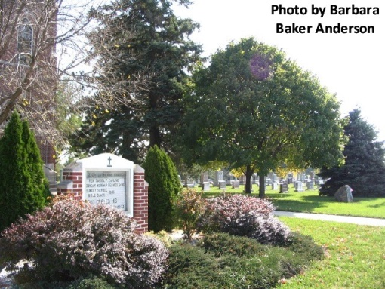
Laurina (Thieme) Conrad, of rural Decatur, Indiana, met her Lord face to face on March 18, 2018. Laurina was a devoted believer of Christ, treasured wife, loving and admired family member, and loyal friend.
She was the eldest of Charles and Flora Thieme's six children, born February 18, 1922 in Union Township, Adams County.
She and her husband, Marvin, most recently celebrated their 76th wedding anniversary on December 27th.
In addition to being a partner with her husband on the family farm, she worked as a bookkeeper for Conrad-Nuerge Construction Company and Williams Elevator. Laurina was a member of Zion Lutheran Church, Friedheim, Lutheran Women's Missionary League, Tabea Society, and Sunny Circle Homemakers Extension Club.
Laurina is remembered for her blunt and practical faith in Jesus Christ. As life's seasons rolled by, her family and friends experienced Christ's love through her. Laurina was proud of her German-Lutheran heritage; chronicling her family's roots in the area. She also loved to photograph life's beauty.
Grieving her passing is her husband, Marvin; daughter, Judy (Dave) Erikson of Homer, Alaska; sons, Dan Conrad of Pataskala, Ohio and Dave (Teri) Conrad of rural Decatur; sisters, Leona Meyer and Marilyn Meyer of Ossian, Indiana; sisters-in-law Ella and Elaine Thieme of Decatur, Indiana. Laurina was also cherished by her granddaughter, Dana (Sean) Engel of rural Monroe; grandsons Darin (Kristen) Conrad of Clarksville, Ohio, Jacob (Jennifer) Conrad of Noblesville, Indiana, and Sam (Jen) Conrad of Wiesbaden, Germany; and granddaughter-in-law Stephanie Conrad of Marion, Indiana. Also surviving are 16 great-grandchildren.
She is preceded in death by her grandson, Aaron Conrad, one sister, Regina Wise, and two brothers: Carl and Wilbert Thieme.
Funeral Services will be held at 10:30 a.m. on Wednesday March 21st at Zion Lutheran Church, Friedheim with Pastor Daniel Dahling officiating. Interment will immediately follow at Zion Lutheran Cemetery, Friedheim. Friends will be received from 4 to 8 p.m. on Tuesday at Zwick & Jahn Funeral Home, Decatur and one hour prior to the service on Wednesday at the church.
Memorials may be made to Zion Lutheran Church Freidheim, Building Fund, or Lutheran Women's Missionary League.

Zwick & Jahn Funeral Home online obit (accessed 3/18/2018)

