Friedericke Bauermeister
May 4, 1870 – December 29, 1960
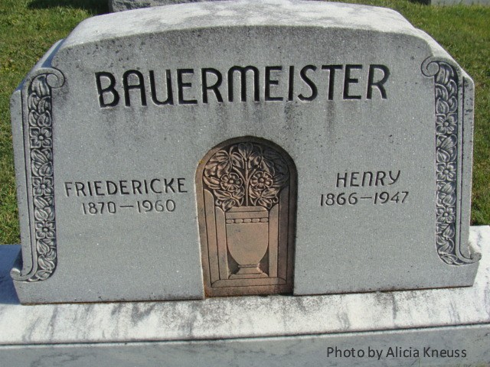
DIES AT AGE OF 90
Mrs. Fredericke Bauermeister, 90, died at her home 4½ miles east of Ossian at 1:45 p.m. Thursday. She was the oldest member of the Zion Lutheran church at Friedheim. Survivors include three daughters living in Adams county, Mrs. Martin Conrad, Mrs. Martin F. Gallmeyer and Mrs. Harvey Bucher, all of the Preble community.

Berne Witness, Adams County, Indiana; Friday, Dec. 30, 1960

Contributed by Karin King

*****
Mrs. Bauermeister Dies at Age of 90

Mrs. Fredericke Bauermeister, 90, died at 1:45 p.m. Thursday at her home 4½ miles east of Ossian. She had been bedfast for four years.
A native of Germany, she had lived here for 67 years.
Mrs. Bauermeister was the oldest member of the Zion Lutheran Church, Friedheim, and a charter member of the church’s Tabai Society.
Surviving are four daughters, Mrs. Martin Conrad and Mrs. Martta F. Gallmeyer, both of Preble Twp., Adams County, Mrs. Harvey Becher, Preble, and Mrs. Alfred Eichler, Jefferson Twp.; two sons, Ernest, Jefferson Twp., and Arthur, Marion Twp, Allen County; 26 grandchildren; 30 great-grandchildren and one great-great-grandchild.
Services will be held at 1:30 p.m. Sunday at the Zwick Funeral Home at Decatur and at 2 p.m. at the church with Rev. A. A. Fenner officiating. Burial will be in the church cemetery.
Friends may call at the funeral home after 7 p.m. today.

Bluffton News-Banner, Wells County, IN: Friday December 30, 1960, p. 1, c. 6

