Larry L. Schaekel
March 14, 1941 – July 28, 1963

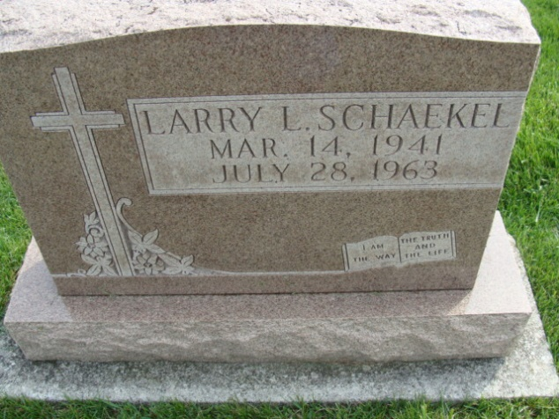
Photo by Alicia Kneuss

Larry Schaekel Is Victim Of Traffic Wreck

Funeral services for Larry Schaekel, 22, of route 2, will be held at 1:30 p.m. Wednesday at the Zwick funeral home, and at 2 p.m. at St. Paul’s Lutheran church, Preble. Burial will be in the church cemetery.
Schaekel, a 1959 Monmouth graduate died at 3:50 a.m. Sunday of a broken neck and multiple fractures received when his car veered into the side of a truck driven by W.J. Yates, Jr., 27, of Little Rock, Ark., six miles north of Fort Wayne on Ind. 427.
Police said he was headed south and crossed the center line. Yates pulled to the right side of the road, but Schaekel’s car hit his left front tie and the left rear dual tires. The impact sheared the side off Schaekel’s car.
David A. Ludwig, 19, of Fort Wayne, a passenger in Schaekel’s car received a deep skull fracture and was termed “extremely critical” by Parkview authorities.
Schaekel was employed in the processing center at the International Harvester company and worked part-time at the South Side Sunoco station in Fort Wayne.
The accident victim was born in Decatur, March 14, 1941, a son of Herman and Mathilda Allmandinger-Schaekel.
He was a member of St. Paul’s Lutheran church at Preble.
Surviving in addition to his parents are two brothers, Norbert Schaekel of Buckley, Ill., and Herman Frederick Schaekel, at home, and one sister, Miss Sharon Schaekel, at home.
The body was removed to the Zwick funeral home, where friends may call after 7 o’clock this evening until time of the services. (Mon. July 29, 1963)

Berne (IN) Library Heritage Room Adams County Obits 1962-1964
Transcribed by Janice Vasilovski

