Otto F. "Moe" Fuhrman
October 21, 1929 – June 15, 2017
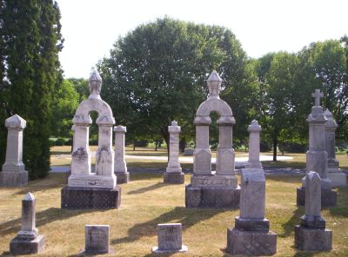
Photo by SixDogTem

Otto F. "Moe" Fuhrman, 87 years old of Decatur, IN, passed away on Thursday, June 15, 2017 at Lutheran Hospital in Fort Wayne following an unexpected illness.
He was born on Monday, October 21, 1929 in Fort Wayne, Indiana, the son of the late Otto Fuhrman and the late Clara (Lahrman) Fuhrman. He married Marlene A. Aumann on June 1, 1957 in St. John Lutheran Church, Bingen.
Otto served in the United States Army National Guard for 12 years. He was a member of St. John Lutheran Church, Bingen where he had served as a trustee, elder, Chairman of the Congregation, and was active in the Men's Club. He was also a Life Member of the Wire Association International and the American Legion Post #43 in Decatur.
Moe was a 1949 graduate of Concordia Lutheran High School. He was the owner and operator, along with Duane Melcher & Larry Saalfrank, of Decatur Wire Die from 1979 to 2000. He was very proud of Decatur Wire Die Services Inc. and the service that the company provided to the Wire Industry Worldwide. Following the transition of Decatur Wire Die Service to the Esteves Group, they then founded DWD Industries LLC in which he maintained an active role until 2014. He had previously worked at Dana Corp., Wayne Hardware, and Hoosier Wire Die.
Moe enjoyed helping others. This belief was passed onto those around him and was best exemplified by his 1,000+ hours of volunteering that he did for the Lutheran Homes (now Lutheran Life Villages) in Fort Wayne.
Surviving are his wife, Marlene A. Fuhrman of Decatur, IN; son, Jon Martin (Danielle) Fuhrman of Decatur, IN; grandson, Jon William Fuhrman of Decatur, IN; granddaughter, Emily Fuhrman of Tallahassee, FL; sister, Ruth Eggers of Fremont, NE; sister, Shirley (Al) Hormann of Decatur, IN; and brother, James (Evie) Fuhrman of Hoagland, IN.
Preceding Moe in death were two brothers, Melvin & William "Bill" Fuhrman; brother-in-law, Harv Eggers; and a niece, Sherry Strasser.
Funeral services will be held at 11:00 a.m. Wednesday, June 21, 2017 at St. John Lutheran Church, Bingen with Pastor Peter Brock officiating. Interment will follow in the St. John Lutheran Cemetery, Bingen.
Friends will be received from 2 to 5 and 6 to 8 p.m., Tuesday, June 20 at Zwick & Jahn Funeral Home in Decatur and one hour prior to the service at the church on Wednesday.
IN LIEU OF FLOWERS, MEMORIALS MAY BE GIVEN IN MOE'S MEMORY TO St. John Lutheran Church, 175th Anniversary Mission (Tanzania); Concordia High School; or Worship for Shut-Ins.

Zwick & Jahn Funeral Home online obit (accessed 6/16/2017)

