Lt. Robert M. Moser
March 24, 1918 – December 13, 1944
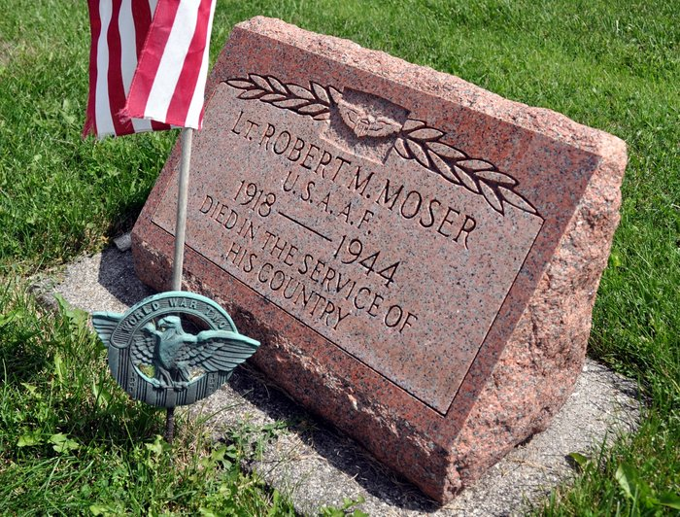
Photo by Deb Curry

The Sikeston Herald, Sikeston, Missouri; December 14, 1944
MALDEN FLIERS KILLED IN CRASH
All four occupants of the Army airplane which crashed on a wooded hill north of Zalma early yesterday morning were instantly killed, it is reported from the Malden Air Base, the ship's home field.
Lieut. Col. Charles A. Cowing, commanding officer of the Malden Air Base, said that the plane was on a routine flight and that a board of qualified observers has been named to inquire into the cause of the accident. The big plane burned after it crashed.
The next of kin of the men who died have been notified. The public relations officer at Malden named them as follows: Second Lieut. Robert Moser, of Decatur, Ind.; Flight Officer Emil P. Ratsy of New Royalton, Ohio; Cpl. Kenneth H. Newell of Seattle, Wash., and Cpl. Wm. H. Schauss of Evanston, Ind.

Contributed by Karin King
*****
LT. ROBERT M. MOSER KILLED IN PLANE
Son of Obed Moser, Bluffton, Killed When His Bomber Crashed Wed.

Mr. and Mrs. Obed Moser of Bluffton, Were shocked and grieved at 3:30 p.m. Wednesday upon receipt of a telegram informing them that their son, Second Lieutenant Robert M. Moser, 26, was killed that day in an airplane crash at Camp Malden, Mo. He was the pilot of a C-47 bomber.
No details concerning the accident were contained in the telegram.
His wife, formerly Delores Worden, a daughter of Mr. and Mrs. Harry Worden, of near Decatur, went to Camp Malden last Sunday to visit him. While making this trip she left their infant son, Max Lee, 18 months, in the care of her parents.
Lt. Moser was making his last routine training flight when the fatal accident occurred. He expected to receive leave to fly to Baer Field, near Fort Wayne, and spend the Christmas holidays with his family.
He was born in Bluffton on March 24, 1918, a son of Obed and Mary Schwartz Moser.
Miss Delores Worden, of near Decatur, became the bride of Lt. Moser in a wedding ceremony performed on Oct. 23, 1941, at Paulding, O. She and their infant son have been residing with her parents while he was in army service.
Surviving besides the widow and the son are his parents; one brother, Pvt. Russell Moser, of the Army Medical corps, who is no in the General Army hospital in England, having been overseas since April, 1944; three sisters, Wanda, Dorothy and Joyce, all at home.
Funeral Services will be held at the Magley Reformed church on Sunday afternoon at 2 o’clock with Rev. Michaels officiating. The body is expected to arrive at Ft. Wayne early Saturday morning

Berne Witness, Adams County, IN; December 15, 1944

*****

LT. MOSER FUNERAL SUNDAY AFTERNOON

Military services will be held at 2 p.m. Sunday at the Salem Evangelical and Reformed church in Magley for Lt. Robert M. Moser, of Bluffton, who was killed in an airplane crash in Missouri Wednesday. A military escort will be furnished b Baer Field. Rev. John Michaels will officiate and burial will be in the church cemetery. The body will arrive in Fort Wayne early Saturday morning and will be removed from the Jahn funeral home in Bluffton to the home of Mrs. Moser's parents, Mr. and Mrs. Harry Worden, Kirkland township, Saturday afternoon.

Decatur Daily Democrat, Adams County, Indiana; Friday, December 15, 1944

Contributed by Karin King

