Helen I. (Diehl) Johnson
June 5, 1918 – April 4, 2010
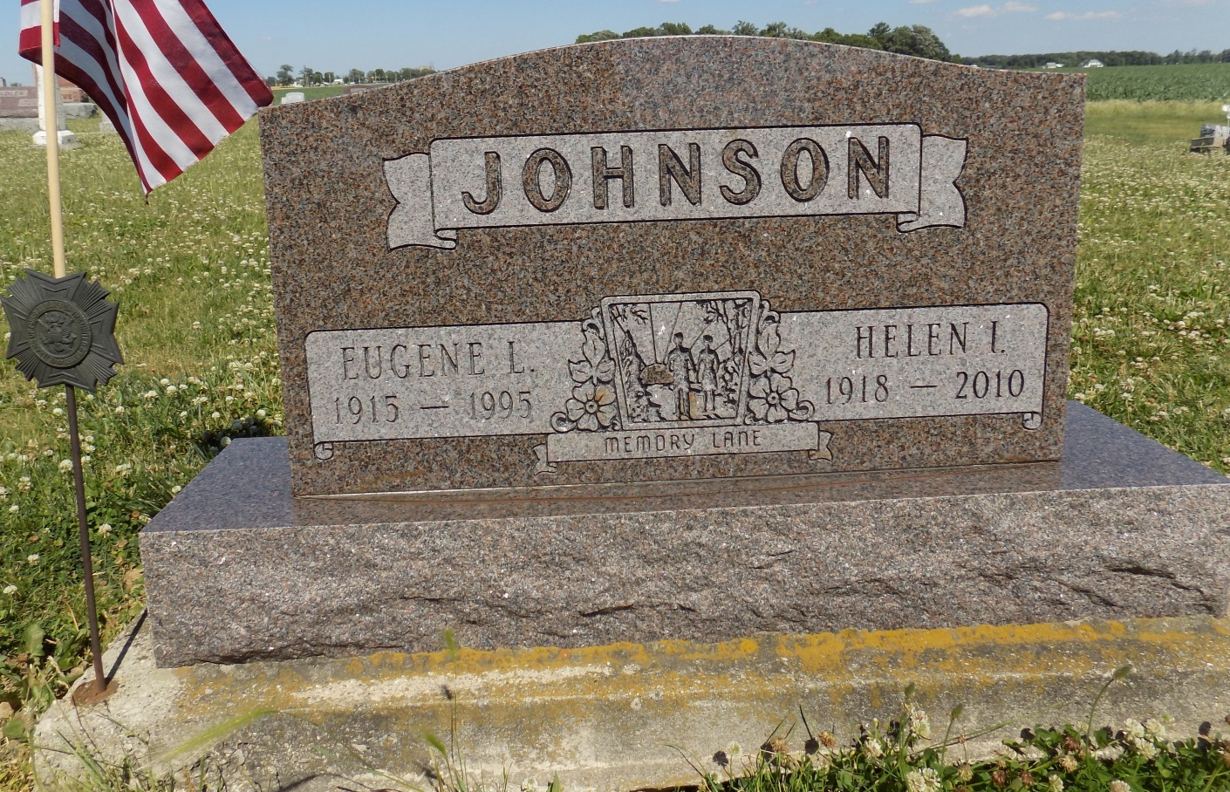
Photo by Margie Roop Pearce

Helen I. Johnson
June 5, 1918 - April 4, 2010

A resident of Wells County since 1923, Helen I. Johnson, passed away Easter morning, Sunday, April 4, 2010, at Bluffton Regional Medical Center. Helen is now with her beloved husband Gene and her son Stan. Helen was a wonderful lady, so loving and caring. She never met a stranger and passed out so much love in her lifetime. The family will miss her but realize she is now with her loved ones baking cookies and making vegetable soup.
She was born in Adams County on June 5, 1918, to Lawrence and Goldie (Graham) Diehl. She married Eugene L. Johnson in Newport, Ky. on Feb. 20, 1937; he preceded her in death in 1995. A 1936 graduate of Lancaster High School, Mrs. Johnson was a homemaker and farmer’s wife. She retired from Keebler’s in 1980 after 11 years of service. She was a member of Murray Missionary Church and Women’s Missionary International.
Surviving relatives include five sons, Dennis Johnson of Fresno, Calif., Tim Johnson of Indianapolis, Thomas Johnson of Bluffton, David Johnson of Coarsegold, Calif. and Steven Johnson of Elkart; two daughters, Janice Wagoner of Brevard, N.C. and Debra Gabbard of Rocky Mountain, N.C.; one brother, Russell Diehl of Bluffton; one sister, Doris Zinn of Bluffton; 22 grandchildren, 32 great-grandchildren and two great-greatgrandchildren. Mrs. Johnson was also preceded in death by one son, Stanley Johnson, four brothers and one sister.
Calling hours will be from 4 to 8 p.m. Thursday at the Thoma/Rich, Chaney & Lemler Funeral Home, 308 W. Washington St., Bluffton, and from 9:30 a.m. Friday at the Murray Missionary Church. Funeral services will be at 10:30 a.m. Friday, at the Murray Missionary Church with Pastor Mike Gilbert officiating. Burial is at Ray Cemetery, in Monroe. Preferred memorials are to the church or Christian Care Retirement Center. Online condolences may be made at www.thomarich.com

Thoma-Rich Hewitt & Chaney Funeral Home online obit (accessed 12/30/2014)

