Abraham Hullinger
December 25, 1871 – May 24, 1931

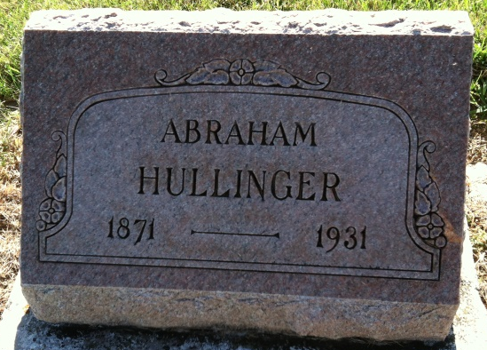
Photo by Barbara Baker Anderson
DECATUR MAN DIES SUNDAY
Abraham Hullinger, 59, Is Victim of Heart Ailment; Ill Day

Abraham Hullinger, 59, Decatur man died at 4:30 o'clock Sunday at his home 1045 Elm Street of heart trouble. Mr. Hullinger had been ailing all winter but had not been bedfast. He worked on his farm Saturday and seemed to be enjoying his usual health when he suddenly became seriously ill Saturday night.
The deceased was employed as a laborer at the Krick-Tyndall Tile Company for the last 21 years. He was born in Darke County, Ohio, December 25, 1871, the son of Jacob and Rachel Hullinger, both deceased.
Surviving is the widow, Mrs. Eliza Burry-Hullinger; four children, Albert Hullinger, Monroe; Mrs. Viola Cable, near Monroe; Irvin Hullinger, Marion; Lawrence Hullinger, at home; five grandchildren; two brothers, William Hullinger, Massilion, Ohio; David Hullinger, Decatur, and a half-brother Mrs. [sic] J. Richord, Decatur. One sister preceded the deceased in death.
The deceased was a member of the United Brethren Church of this city for many years.
Funeral services will be held Wednesday morning at 9:30 o'clock at the home and at 10 o'clock at the United Brethren church with Rev. R. E. Vance officiating. Burial will be in the Ray Cemetery at Monroe.

Decatur Daily Democrat, Adams County, Indiana
Monday, May 25, 1931

