Melvin M. Hirschy
October 19, 1920 – October 24, 2004

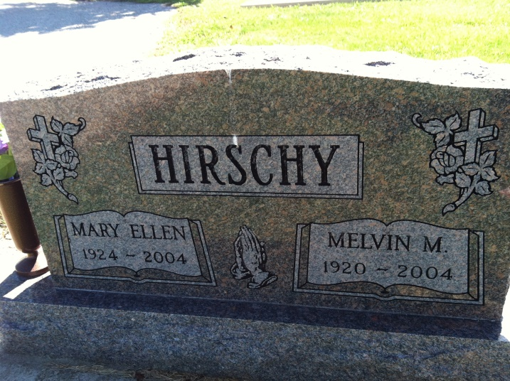
Photos by Barbara Baker Anderson

Melvin M. Hirschy 84, passed away on Sunday, Oct. 24, 2004 at his residence. His parents were Alfred P. and Minnie Ellen (Burkhart) Hirschy. He was born in Adams County, IN on Oct. 19, 1920. He married Mary Ellen (Confer) on Dec. 24, 1941 she died on Aug. 8, 2004.
Survived by 4 sons - Edward Hirschy, Decatur; Gary Hirschy, Monroe; Dean Hirschy, Craigville; and Randy Hirschy, Monroe. 5 daughers - Mrs. Lynn (Linda) Lehman, Monroe; Mrs. Steve (Judy) Affolder, Berne; Mrs. David (Bonnie) Dolch, Monroe; Mrs. Gary (Kathleen) Affolder, Ossian; Mrs. Kevin (Lori) Foster, Monroe. 3 sisters Mrs. Arthur (Rebecca) Werst, Berne; Mrs. Charles (Ardena)Lehman, Berne; Mrs. Lee (Arlene Sue) Sprunger, Berne. 31 grandchildren and 29 Great Grandchildren.
Preceded in death are 2 brothers Glen & Russel Hirschy, 1 grandson Michael Dee Hirschy.
Visitation will be on Tuesday, Oct. 26 from 6-8 p.m. and on Wednesday, Oct. 27 from 2-8 p.m. at the funeral home. Funeral will be at 10:00 a.m. on Thursday, Oct. 28 with calling 1 hour before at the Cross United Church of Christ, Berne, IN. Burial will be at the Ray Cemetery in Monroe, IN with Rev. Randall Luther officiating. There will also be Military Grave Side Rites by American Legion Post #43. Memorials are to Cross United Church of Christ Tape Ministry and MooseHeart.

Haggard - Sefton & Hirschy Funeral Home, Adams County, IN
June 6, 2011
*****

Melvin M. Hirschy, 84, of rural Bluffton, died at 11:14 a.m. Sunday at home. He was born on October 19, 1920, in Adams County to Alfred P. and Minnie E. Burkhart Hirschy. He married Mary Ellen Confer on December 24, 1941; she died on August 8 this year.
He was a retired employee of General Electric Co. and a retired farmer who was a member of Cross United Church of Christ in Berne and to Moose Lodge 1311 in Decatur. He was a member of the GE firefighting force and a former menber of the American Legion and the Red Men's Lodge.
During World War II, he served in the U.S. Army Air Corps.
Surviving are four sons, Edward L. Hirschy of rural Decatur, Gary L. and Randy W. Hirschy, both of Monroe, and Dean A. Hirschy of Craigville; five daughters, Mrs. Lynn (Linda L.) Lehman, Mrs. David (Bonnie J.) Dolch, and Mrs. Kevin (Lori A.) Foster, all of Monroe; Mrs. Steve (Judith E.) Affolder of rural Berne; and Mrs. Gary (Kathleen J.) Affolder of Ossian; three sisters, Mrs. Arthur (Rebecca) Werst, Mrs. Charles (Ardena) Lehman, and Mrs. Lee (Arlene Sue) Sprunger, all of Berne; 31 grandchildren; and 29 great-grandchildren. Two brothers and a grandson are deceased.
Funeral services will be held at 10 a.m. Thursday in Cross United Church of Christ, with burial in Ray Cemetery, rural Monroe, including military graveside rites by the color guard from American Legion Post 43 in Decatur. Visiting hours are 6-8 p.m. Tuesday and 2-8 p.m. Wednesday in Haggard and Sefton Funeral Home, Decatur, and 9-10 a.m. Thursday in the church.
Preferred memorials are to the tape ministry at the church and to Mooseheart in Illinois.

Decatur Daily Democrat, Adams Co, IN; Monday, October 25, 2004
*****

Melvin M. Hirschy, 84, rural Bluffton, died at 11:14 a.m. Sunday, Oct. 24 at his residence.
Born in Adams County on Oct. 19, 1920 to Alfred P. and Minnie Ellen Burkhart Hirschy, he married Mary Ellen Confer on Dec. 24, 1941; she died Aug. 8, 2004.
A retired G.E. employee and farmer, he was a member of the Cross United Church of Christ in Berne, G.E Firemen, Moose Lodge 1311 in Decatur, and a former member of the American Legion and the Redmens Lodge.
Survivors include four sons, Dean A. Hirschy of Craigville, Edward L. Hirschy of Decatur, and Gary L. and Randy W. Hirschy, both of Monroe; five daughters, Mrs. Gary (Kathleen) Affolder of Ossian, Mrs. Steve (Judith) Affolder of Berne, Mrs. Lynn (Linda) Lehman, Mrs. David (Bonnie) Dolch, and Mrs. Kevin (Lori) Foster, all of Monroe; three sisters, Mrs. Arthur (Rebecca) Werst, Mrs. Charles (Ardena) Lehman and Mrs. Lee (Arlene Sue) Sprunger, all of Berne; 31 grandchildren; and 29 great-grandchildren. He was preceded in death by two brothers, Glen and Russel Hirschy, and one grandson.
Services will be held Thursday at 10 a.m. at the Cross United Church of Christ in Berne. Calling hours are Tuesday from 6 to 8 p.m., and Wednesday from 2 to 8 p.m. at the Haggard & Sefton Funeral Home in Decatur, and for one hour prior to the service Thursday at the church. Graveside military rites by American Legion Post 43, with burial in the Ray Cemetery near Monroe.
Preferred memorials to the church's tape ministry and the MooseHeart Home.
Bluffton News Banner, Wells County, Indiana; Oct. 25, 2004

