S/Sgt. Calvin George Hahnert
July 22, 1921 – March 3, 1944

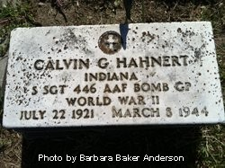
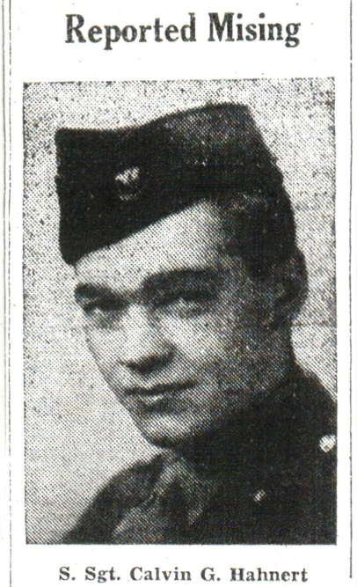
REPORT SGT. C. HAHNERT, MONROE, MISSING IN ACTION
Mrs. Alfred Hahn Informed Sunday; Chief Gunner on Liberator

Staff Sergeant Calvin C. Hahnert, aged about 26, son of Mr. and Mrs. Eliza Hahnert of Monroe, is reported missing in action over Germany, according to a telegram received from the adjutant general of war department. S. Sgt. Hahnert was a chief gunner on a B-24 Liberator bomber based in England, and according to the telegram he has been missing in action over Germany since March 8. The last letter his mother received from him was written on March 7 in which he stated that he had about finished his quota of missions over enemy territory before being granted a furlough home. In that letter he stated that he expected to be home in about a month. On the following day however, he failed to return from a mission and his fate may not be known for some time.
The telegram stated that a letter would follow, which will probably be only a verification of the telegram. S. Sgt. Hahnert entered the air forces on October 1, 1942, having enlisted in the service. After graduating from Monroe High School he attended Purdue university. Upon entering the service he received gunner's training at Las Vegas, Nev, and dive bombing training in Tennessee. He has been overseas since last November. His father was the late Alfred Hahnert who died a year ago.

The Berne Witness, Adams County, IN; March 27, 1944
Sgt. Hahnert, Long Missing, Is Now Presumed To Be Dead

Staff Sgt. Calvin G. Hahnert, 23, son of Mrs. Eliza M. Hahnert, and the late George A. Hahnert of Monroe, who has been missing in action over Berlin, Germany, since March 8, 1944, is now presumed to be dead, the war department has notified the mother.
S/Sgt. Hahnert, a gunner on a B-24 Liberator, was on a volunteer bombing mission over
Germany, from which he did not return. No word of his whereabouts has been
received by the war department. His plane was seen to crash in the vicinity of Celle, in
Northwestern Germany. It has never been learned if he parachuted to safety.
The young gunner was one of six men out of his group to volunteer for the special bombing mission, from which 65 planes failed to return. He had 15 missions to his credit, 13 of which had been made with his regular crew. He had received the air medal, with three Oak Leaf clusters. He and his crew had also been cited for "exceptional meritorious achievement, while participating in separate bomber combat missions over enemy-held territory."
S/Sgt. Hahnert was born in Monroe, July 22, 1921. He was graduated from Monroe
high school and had attended Purdue university. He enlisted in the Eighth Army Air
Corps on Oct. 1, 1942, and received gunnery training at Denver, Col., bombardier
training at Las Vegas, Nev., and dive bombing training in Tennessee.
Besides his mother, he is survived by three brothers, Herman of Fort Wayne; Don of
Hartford City, and Howard of Urbana, and two sisters, Mrs. Alta Row of Fort Wayne
and Mrs. Lee Miller of Bluffton.
His mother is still hopeful that word of his safety may be received.

Decatur Daily Democrat, Adams Co, IN; March 20, 1945
*****
S. SGT. HAHNERT, LONG MISSING PRESUMED DEAD
Mother at Monroe notified Son now listed as dead

Staff Sergeant Calvin G. Hahnert, 22, son of Mrs. Eliza M. Hahnert and the late George A. Hahnert of Monroe, who has been missing in action over Berlin, Germany, is now presumed to be dead, the war department has notified the mother.
S/Sgt. Hahnert, a gunner on a B-24 Liberator was on a volunteer bombing mission when he failed to return. His crew was based in England and a thousand planes went for a raid on Berlin on March 8, 1944 and were on their return home from Nazi capitol back to England. They were in combat with the enemy and accompanying planes saw their plane fall in the vicinity of Celle, Germany. No information has ever been found of the outcome of the fall where 65 planes that failed to return from that mission.
The younger gunner was one of six men out of his group to volunteer for the special mission. He had received two air medals, two oak leaf clusters and was in line for another medal on finishing that trip that day, which would have been his fifteenth volunteer mission he had made thirteen trips with his regular crew in which he received four ribbons.
Sgt. Hahnert was born in Monroe, July 22, 1921. He graduated from Monroe High School and attended Purdue University. He enlisted and was in the Eighth Air Corps, October 1, 1942. He received bombardier training at Las Vegas Nevada; gunnery training in Colorado and dive bombing in Tennessee.
Besides his mother he is survived by three brothers and two sisters, Herman of Fort Wayne; Don of Hartford City, and Howard of Urbana, Mrs. Alta Row of Fort Wayne and Mrs. Lee Miller of Bluffton. His mother is still hopeful that word of his safety may be received later.

IN MEMORIAM

The mother of Staff Sergeant Calvin G. Hanert, who has been listed as dead, since missa a year in action, is still hopeful that word of his safety may be received, but if not she takes comfort in the thought-
Even for the dead I will not bind my soul to grief.
Death cannot long divide, for is it not as though the rose that climbed my garden wall Had blossomed on the other side? Death doth hide, but not divide. Thou art but on Chris's other side; Thou art with Christ and Christ with me; In Christ united still are we.

Berne Witness, Adams County, IN; March 21, 1945

*****

GETS PURPLE HEART FOR MISSING SON

Mrs. Eliza May Hahnert, of Monroe, has received the Purple Heart awarded to her son, Staff Sgt. Calvin G. Hahnert, 23, who was reported missing over Berlin Germany on March 8, 1944 and "presumed to be dead" a year later. Sgt. Hahnert was a gunner on a B-24 Liberator bomber and was on a Volunteer mission when the fatal accident happened. He had 15 regular missions to his credit. Previously he had received the air medal with three oak leaf clusters. The young man enlisted in the army air corps in October, 1942.

Berne Witness, Adams County, IN; April 23, 1945

Articles provided by Berne Library Heritage Room Staff
Transcribed by Gabriella Brouillette Smith

