Infant Son Hahn
August 13, 1906 – August 14, 1906

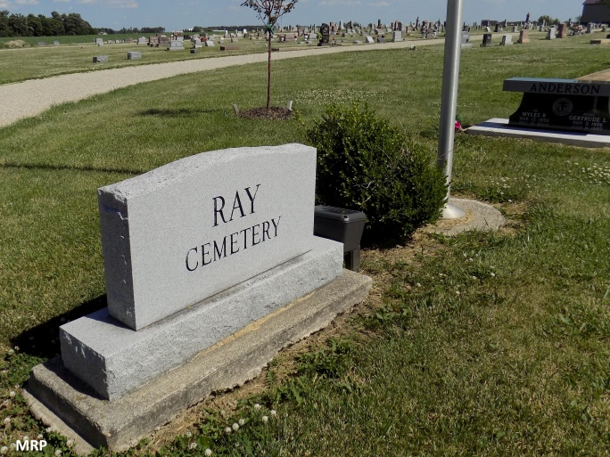
Info from Karin King

The infant child of Mr. and Mrs. James Hahn, who reside in the south part of the city, was buried this morning at the Ray cemetery near Monroe. The child died last evening.

Decatur Democrat, Adams County, Indiana (a weekly newspaper) Thursday, Aug. 16, 1906
*****

The funeral services for the infant son of Mr. and Mrs. James Hahn, occurred at their home, on South Fifth street, Tuesday. Short services at the house at 10 o'clock, was conducted by Rev. D. B. Reckard, after which the remains were taken east of Monroe, for burial, the former home of the parents.

Decatur Democrat, Adams County, Indiana (a weekly newspaper); Thursday, Aug. 16, 1906
*****

Indiana, Death Certificates, 1899-2011

Name: Infant Mr and Mrs J Hahn
Gender: Male
Race: White
Age: 1 day
Birth Date: Aug. 13, 1906
Birth Place: Decatur Inda
Death Date: 14 Aug 1906
Death Place: Decatur, Adams , Indiana, USA
Father: James Halm
Mother: Lena Dehl
Burial: Aug. 14, 1906; Ray Cem.

