Virginia M. (Springer) Gephart
September 4, 1921 – August 7, 1990
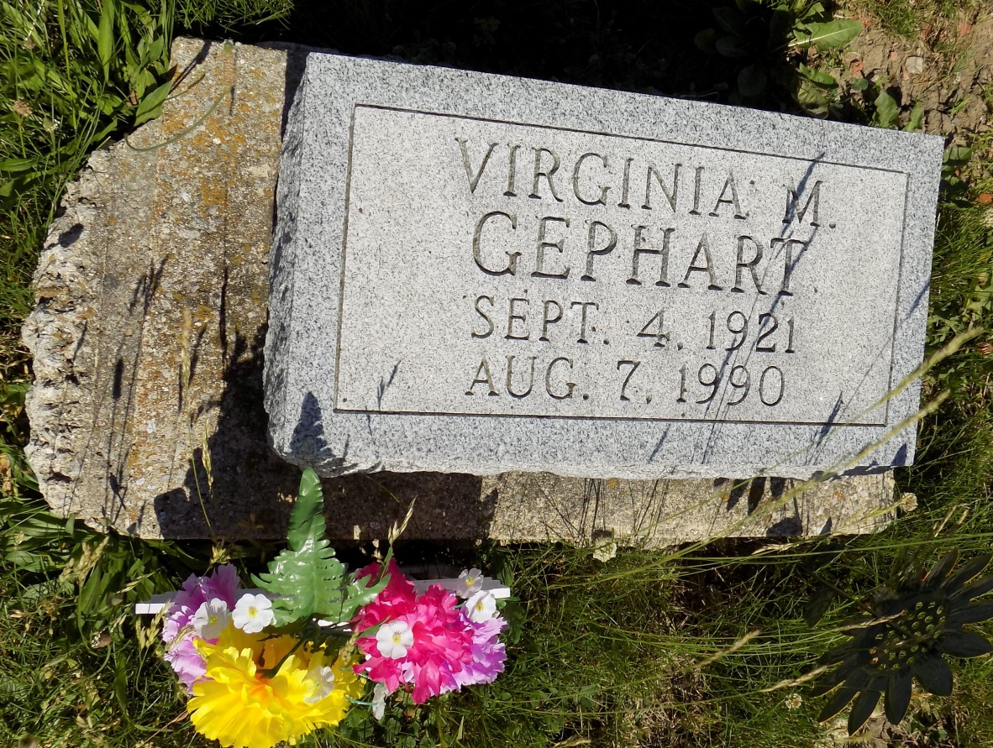
Photo by Margie Roop Pearce

Virginia M. Gephart, 68, formerly of 237 1/2 W. Monroe St., died at 7 a.m. today in Lakeside Manor. She was born on September 9, 1921 in Adams County to John and Susie Springer and married Ernest Gephart; he died in 1946. Surviving are a daughter, Mrs. Tom (Sharon) Fulton, 221 Piedmont Dr.; two sons, John Gephart, Hudson, Indiana, and Roger Agler, 237 1/2 W. Monroe St.; a sister, Mrs. Paul (Margie) Wagner, Cloverdale, Ohio; a half-sister, Dollie Stahl, Lakeside Manor; two half-brothers, William and Lawrence Springer, both of Kalamazoo, Michigan; nine grandchildren; and seven great-grandchildren. One daughter, Linda Dawson, and two brothers, Calvin and Homer Springer, are deceased. Funeral services are at 10 a.m. Thursday in Haggard and Armes Funeral Home, Rev. Brian White officiating. Burial will be in Ray Cemetery, east of Monroe. Visiting hours are 2-5 and 7-9 p.m. Wednesday.

Decatur Daily Democrat, Adams Co, IN, Tuesday, August 7, 1990

