William Brandyberry
December 16, 1867 – September 16, 1946

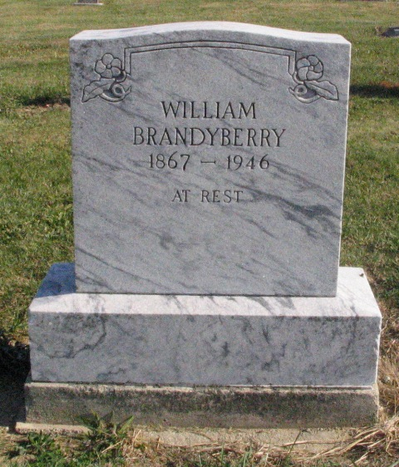
Photo by Barbara Baker Anderson
Obit from Karin King

Brandyberry Rites To Be Wednesday
Wm. Brandyberry Is Taken By Death
Funeral services will be held Wednesday afternoon at 1:30 o'clock at the Lobenstein funeral home and 2 o'clock at the Monroe Friends church for William Brandyberry, 78, who died early Monday at his home in Monroe.
The Rev. Robert Miller, church pastor, will officiate, assisted by the Rev. William Kindle.
The deceased was born in Adams county, the son of Alexander and Sarah Brandyberry. Survivors include three sisters, Mrs. Rebecca Urick, Decatur, Mrs. Isabelle Urick, Dunkirk, and Mrs. Alice Sprunger, Anderson; a brother, John Brandyberry of Arkansas. A daughter, brother and three sisters are deceased.

Decatur Daily Democrat, Adams Co, Indiana
Tuesday, 17 September 1946

