Richard W. Andrews
February 28, 1919 – June 22, 1989

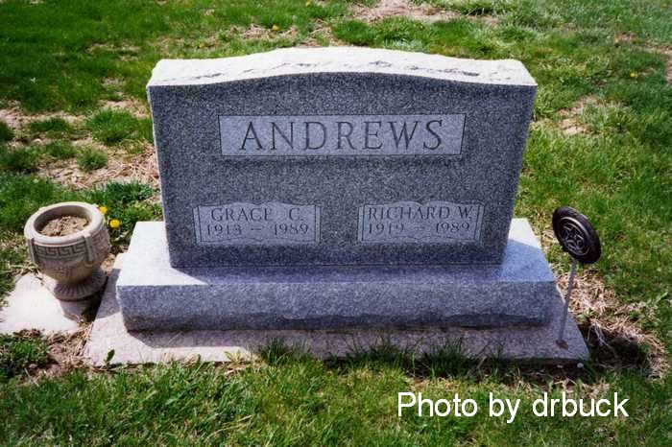

Decatur Public Library (Adams Co, IN) online obit index
Title: Andrews, Richard W.
Publication: Decatur Public Library; Date: 23 JUN 1989
Abstract: Age 70
Died: Thursday, June 22, 1989
Born: February 28, 1919
Son of: Harry C. & Mary E. Wisely Andrews
Married: Grace A. Carter on March 20, 1969
Subjects: Obituaries -- A -- 1980-1989

*****
Indiana, Death Certificates, 1899-2011

Name: Richard W Andrews
Gender: Male
Race: White
Age: 70
Marital status: Married
Birth Date: 28 Feb 1919
Birth Place: Decatur, Indiana
Death Date: 22 Jun 1989
Death Place: Decatur, Adams, Indiana, USA
Father: Harry C Andrews
Mother: Mary E Wiseley
Spouse: Grace A Andrews, informant
Burial: June 25, 1989, Ray Cemetery

