Harrison Andrews
July 18, 1892 – August 16, 1969

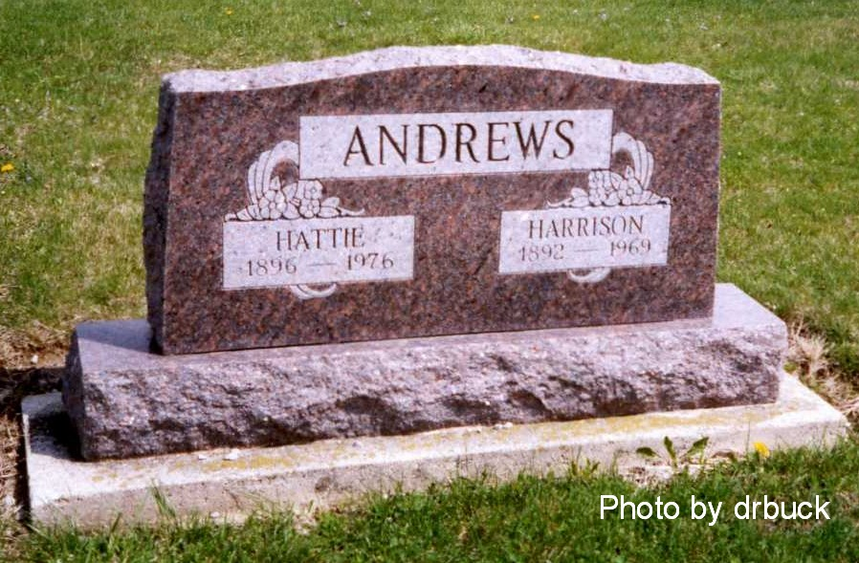
Obit from Karin King

Harrison Andrews Dies Unexpectedly

Harrison Andrews, 77-year-old retired framer, died suddenly at 45 o'clock this morning at his home on Monroe route 1.
A lifelong resident of Adams County, he was born in Washington Towsnhip, July 18, 1892, to Joe and Jane Russel-Andrews, and was married to Hattie Hoffman January 24, 1921.
A veteran of World War I, Mr. Andrews served in Europe from September 20, 1917 until June 13, 1919. He was a member of the American Legion and the Veterans of Foreign Wars.
Surviving in addition to his wife are one son, Jack Andrews of Decatur route 4; one sister, Mrs. Harvey (Ollie) Culbertson of Decatur route 5; and seven grandchildren. One brother and one sister are deceased.
Funeral services will be held at 1:30 p.m. Monday at the Zwick Funeral Home with burial in the Ray Cemetery, west of Monroe, with military services at the grave by the American Legion and the VFW.
Friends may call at the funeral home from 7 to 9 p.m. today and after 6 p.m. Sunday.

Decatur Daily Democrat, Adams County, Indiana
Saturday, August 16, 1969

