Rachel P. (Steury) Schwartz
August 29, 1903 – November 1, 1987
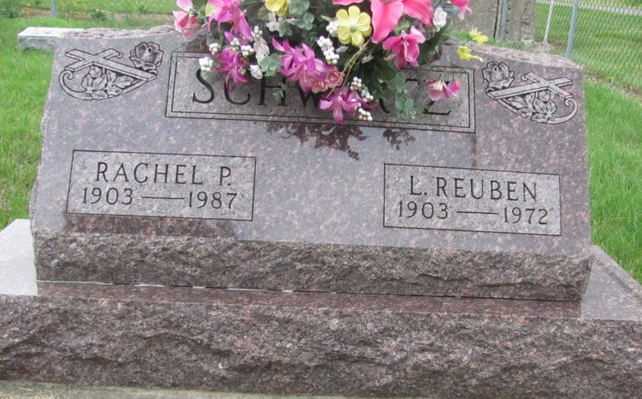
Photo by Jenna Langston

Adams Public Library System (Decatur, IN) online obits
Publication: Decatur Daily Democrat; Date: 02 NOV 1987
Title: Schwartz, Rachel P.
Subject: Obituaries -- S -- 1980-1989
Abstract: Age: 84
Died: November 1, 1987
Born: August 29, 1903
Married: Reuben Schwartz - December 25, 1926
Notes: DPL Scrapbook 7-79-2

