Leah (Graber) Schwartz
October 13, 1899 – August 31, 1981

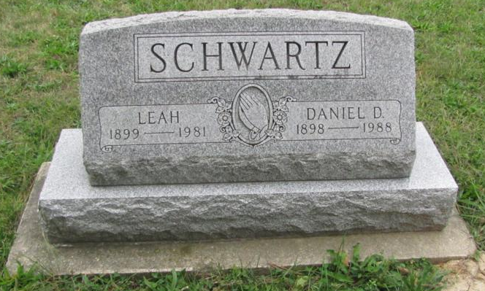
Photo by Jenna Langston

Adams Public Library System (Decatur, IN) online obits
Publication: Decatur Daily Democrat; Date: 31 AUG 1981
Title: Schwartz, Leah
Subject: Obituaries -- S -- 1980-1989
Abstract: Age: 81
Died: August 31, 1981
Born: October 13, 1899
Daughter of: Peter F. & Rosina Mazelin Graber
Married: Daniel D. Schwartz - June, 1921

