Mildred (Manley) Wolfe
February 22, 1919 - March 3, 2016

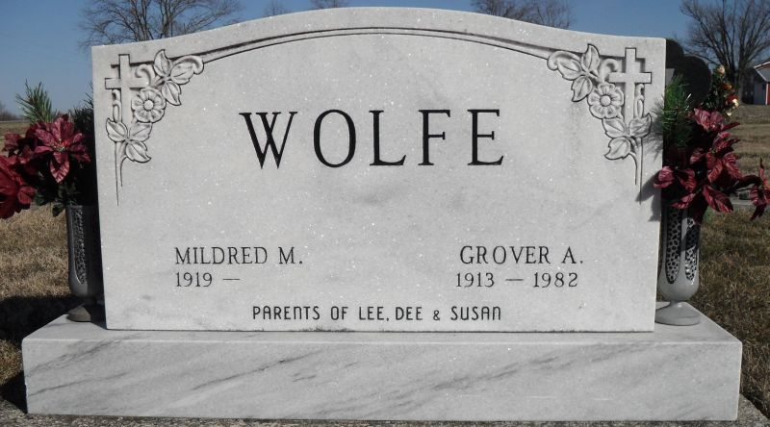
Photo by Stephen & Andrea Brangan

Mildred M. Wolfe, 97 years old of Berne, Ind., and a longtime resident of Pleasant Mills, Ind., passed away on Thursday, March 3, 2016 at Swiss Village.
She was born on Saturday, February 22, 1919 in Adams County, Indiana the daughter of the late Chauncey O. Manley and the late Mae M. (Julian) Manley. She married Grover A. Wolfe on April 4, 1936 in Michigan and he preceded her in death on December 25, 1982.
Mildred was a member of Pleasant Mills United Methodist Church.
She was a homemaker and had babysat for 29 years. She had also worked at J.C. Murphy's for seven years and volunteered at Adams Memorial Hospital for several years. Mildred loved gardening and flowers.
Surviving are her twin son, Clyde "Dee" (Shirley) Wolfe of Decatur; twin son, Chauncey "Lee" (Donna) Wolfe of Decatur; daughter, Susan Ann (Tony) Landis of Decatur; sister, Velma (Jim) Penrod of Bluffton; sister, Marcile (Leonard) King of Decatur; and brother, Kenny Manley of Decatur. She is also survived by eight grandchildren, Denny (Cheryl) Wolfe; Nancy (Randy) Hirschy; LeAnn Northam; Brian (Susan) Wolfe; Melinda Wolfe; Ryan (Amber) Landis; Lindsey (Michael) Marlow; Whitney (Josh) Smith; 16 great-grandchildren, and 18 great great-grandchildren.
Preceding Mildred in death were a granddaughter, Cathy Wagner; six sisters, Edna Manley; Violet Roe; Mable Miller; Esther Cook; Jean Cook; and Lois Kaufman; and three brothers, Richard Manley; Glen Manley; and Lester Manley.
Funeral services will be held at 2:00 p.m. Sunday, March 6, 2016 in the Zwick & Jahn Funeral Home in Decatur with Pastor Ernie Suman officiating. Interment will follow in the Spring Hill (Backesto) Cemetery. Friends will be received from 3 to 8 p.m., Saturday, March 5 and from 12 noon to 2 p.m. Sunday, March 6 in the Zwick & Jahn Funeral Home in Decatur.
Preferred memorials are to Pleasant Mills United Methodist Church or Swiss Village.
Zwick & Jahn Funeral Home online obit (accessed 5/22/2017)

