Quillar Buffenbarger
May 5, 1880 – December 5, 1911

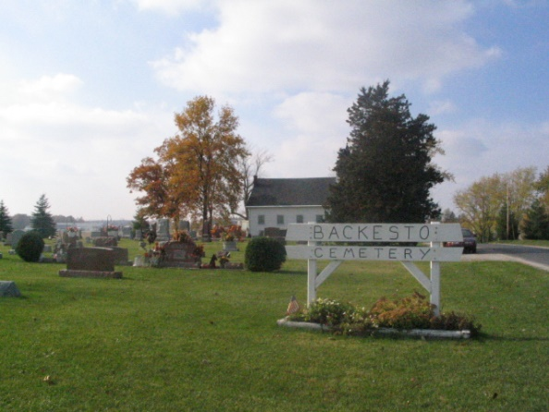
Photo by Barbara Baker Anderson

BUFFENBARGER FUNERAL

The funeral of Quillar Buffenbarger of north of Decatur, whose death occurred Tuesday morning at 10:30 o'clock from tuberculosis, was held Thursday morning at the house at 8:30 o'clock, in charge of the Rev. D. O. Wise of the Evangelical Church, after which the body was taken to the Spring Hill Evangelical church, northeast of Berne, where the Rev. Wise conducted another service.
Burial was made in the cemetery at that place, where a brother and sister and other relatives of the deceased have been laid.
Mr. Buffenbarger leaves besides his wife, three sons - Lawrence, Forest and Harvey; also his parents, Mr. and Mrs. John Buffenbarger, and three brothers - Henry, Mark and Alva, of Decatur.

Berne Witness, Adams County, Indiana
Friday, December 8, 1911
*****

Note: Death Cert gives birth as May 5, 1880 and death Dec. 5, 1911; buried Dec. 7, 1911 Backesto Cemetery

