Homer L. Liby
August 13, 1905 – September 19, 1961

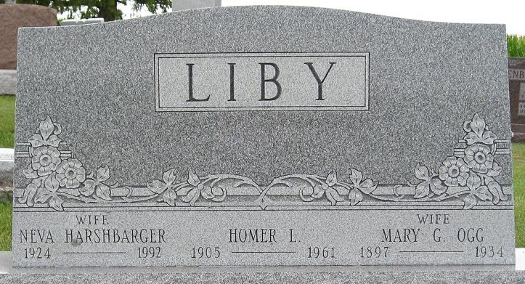
Photo by Deb Curry
Homer Liby Is Dead From Heart Attack
Homer Liby, 56, of Decatur route 3, a veteran employee of the Decatur plant of the General Electric Co., died suddenly while at work. Death was caused by a coronary occlusion. He had not been ill.
He was born in Adams County August 13, 1905, a son of Adam and Malena Hilge-Liby, and was married to Neva Harshbarger June 19, 1945.
Mr. Liby, employed for years in the plating department at the Decatur plant, was a member of the Bethany Evangelical United Brethren Church, the Loyal Order of Moose, and the G. E. Quarter Century club.
Surviving in addition to his wife are a daughter, Mrs. Jay (Phyllis) Minch of Decatur; four sons, Doyle, Ronald, Jerry and Jay Liby, all at home; five grandchildren; two brothers, Alva Liby of Bluffton, and Lawrence Liby of St. Petersburgh, Fla., and one sister, Mrs. Lucille Ross of Decatur. One sister is deceased.
Funeral services will be conducted at 1:30 p.m. Friday at the Black Funeral Home and at 2 p.m. at the Bethany E. U. B. Church, the Rev. F. P. Miller officiating. Burial will be in St. Luke's Cemetery, southwest of Decatur. Friends may call at the funeral home after 7 p.m. today until time of the services.

Decatur Daily Democrat, Adams County, Indiana
Wednesday, September 20, 1961

