David Liby
April 15, 1840 – November 13, 1913
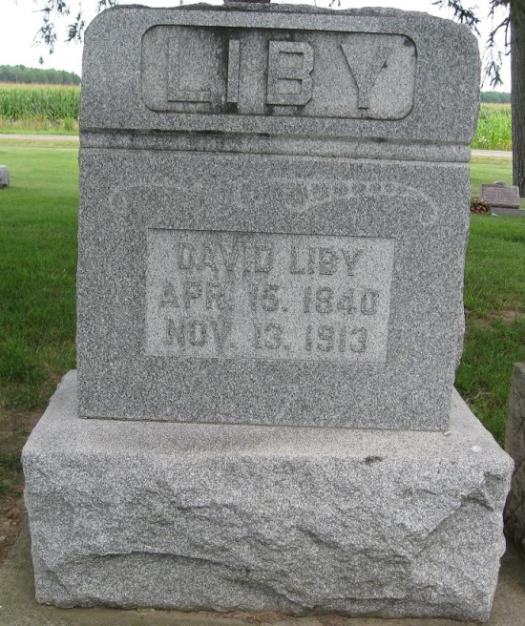
Photo by Janet Haughey

DAVID LIBY DIED SUDDENLY
Well Known Farmer Drops Dead on Road While En-Route to This City; Attempted to Get Out of Rig and Dropped Dead Between the Wheels.
One of the most sudden and unexpected deaths occurred this morning about 9:45 o'clock, when David Liby, a well-known farmer of Preble, suddenly dropped dead while driving to this city with his wife to attend to some trading. While driving along the road between the homes of Phil Baker and John Schurger, Mr. Liby remarked to his wife that he was feeling rather ill and thought that he would get out of the buggy for a minute. He stopped the horse and was making an attempt to reach the step with his foot, when he suddenly collapsed and fell between the wheels of the buggy. The screams of Mrs. Liby attracted the attention of mail carrier Earl Butler, and also Mr. Baker. They hastened to the buggy and not knowing that Mr. Liby was dead hastily sent a call for Dr. C. S. Clark.
Upon his arrival the physician announced that death had been instantaneous, and was due, as far as the meager examination at that time could disclose to paralysis of the heart.
Mr. Liby, prior to this attack, had suffered two similar attacks of paralysis, the second attack being so severe that he lay for weeks between life and death, finally rallying, but as a result was impeded in his walk.
Mr. Liby was born in Ohio sixty-five years ago. He moved to this county during the Civil War and when about twenty-four years of age, locating in Kirkland Township. Later he sold his property in that township and moved to Root Township. Several months ago he moved to Preble at which place he resided up to the time of the death.
Mr. Liby entered into the bonds of matrimony three times during his life, he being survived by his third wife, who was formerly Mrs. Belle Swigart. He is also survived by two children, they being Mrs. Charles Bell of Craigville, and William Liby, of Monroe, one daughter, Mrs. Elizabeth Whitehurst, having preceded him in death. Five grandchildren also survive.
Mr. Liby was one of the best known farmers in Adams County, he always being in the lead and assisting in every way possible every moment that would in any way benefit the county and residents. He was a kind, big-hearted man, ready and willing to help anyone in distress even to the point of depriving himself, and it will take years to heal the scar of sorrow that his departure from this life has made.
Decatur Daily Democrat, Adams County, IN; November 13, 1913

