Richard Henry High
May 8, 1917 – August 11, 1928

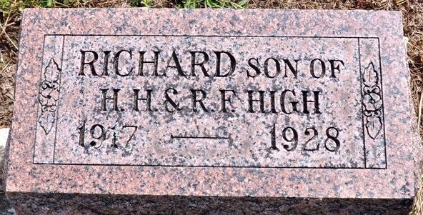
Photo by Deb Curry

H. H. HIGH'S SON IS KILLED IN FALL OFF PONY
11-Year-Old Adams County Boy Is Victim of Accident
Richard High, 11, son of Mr. and Mrs. H. H. High, one mile east of Honduras, in Adams County, died this morning at 11 o'clock of injuries received two hours before when a pony he was riding stumbled over a hog, throwing the boy.
The boy never regained consciousness. Examination revealed that he had suffered a concussion of the brain on the left side of his dead and a punctured lung. Dr. Grandstaff, of Preble, and Dr. Smith, of Decatur, were hurriedly summoned, but medical aid was futile. Just how the injuries were inflicted will never be known as the only witness to the tragedy was Richard's little 5-year-old brother, Robert. It is thought likely that the pony fell on Richard after tumbling. The animal was an exceptionally tame one.
Richard was in the act of driving colts across a field when the accident happened. His brother, seeing the accident, ran at once to his mother, who was first to her son's assistance. An uncle, Jesse Crum, was also there at the time.
The parents and the little brother survive. The mother was formerly Miss Ruth Crum, daughter of Mrs. Frank Crum, with whom the High family lives.
Funeral service plans had not been completed late this afternoon.

Bluffton Evening News, Wells County, Indiana
August 11, 1928
*****
Indiana, U.S., Death Certificates, 1899-2011
Name: Richard Henry High
Gender: Male
Race: White
Age: 11
Marital status: Single
Birth Date: 8 May 1917
Birth Place: Adams Co Indiana
Death Date: 11 Aug 1928
Death Place: Kirkland, Adams, Indiana, USA
Father: Hibiert High
Mother: Ruth Crum
Burial: August 13, 1928; Zion Cemetery

