William F. Fulk
December 19, 1841 – May 21, 1916

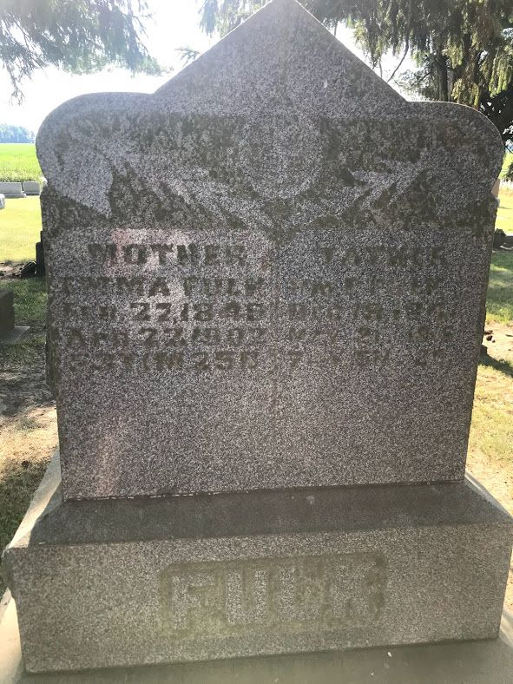
Photo by SMMR

The body of William Fulk, father of John H. Fulk, of this city, was brought here Tuesday forenoon from Warren, O., where the aged man's death occurred Sunday. Mr. Fulk was visiting a sister at the time of death, having gone to Warren two months ago. His home for many years was made three miles south of Bluffton.
The funeral services will be held at 2:00 o'clock Thursday afternoon at the home of his son in this city and burial will be at Honduras.
He is survived by three sons, John Fulk, of this city; Louis Fulk, of Chicago, and Edward Fulk, residing in Texas.

Fort Wayne News, Allen County, Indiana
May 24, 1916
*****
MR. FULK DIES AT WARREN, OHIO HOME DURING GREATER PART OF LIFE MADE NEAR BLUFFTON

John H. Fulk, living at the corner of Oak and Cherry Streets, was this morning called to the vicinity of Warren, Ohio, by the death of his father, William Fulk, aged about seventy-one years. Mr. Fulk passed away at the home of his sister, where he had been visiting for the last two months. His home during the greater part of his life had been made on a farm three miles south of Bluffton.
Mr. Fulk's death was due to ulcers of the stomach. He had been ailing in health for more than a year, but his condition had not been serious until late.
He is survived by three sons, John Fulk, of this city; Louis Fulk, of Chicago, and Ed Fulk, residing in Texas; a brother, Peter M. Fulk, residing nine miles east of the city and a sister, Mrs. Catherine Liby, residing five miles east of the city. Other brothers and sisters, besides the sister at Warren, live in Ohio.
Arrangements have been made to bring the body to the home of the son, John, in this city. The cortege will leave Warren at 6 o'clock tomorrow morning and will arrive here on the Clover Leaf train about 11 o'clock tomorrow morning. The funeral services will be held at the residence at 2 o'clock Thursday afternoon and burial will be at Honduras.

The Evening Banner, Wells County, Indiana
May 22, 1916
*****
Name: William F Fulk
Event Type: Death
Event Date: 21 May 1916
Event Place: Niles, Trumbull, Ohio
Residence Place: Ohio
Sex: Male
Age: 75
Marital Status: Widowed
Race: w
Occupation: Retired Farmer
Birth Date: 19 Dec 1841
Birthplace: Warren
Burial Date: 25 May 1916
Burial Place: Bluffton, Ind.
Father's Name: Jacob Fulk
Father's Birthplace: Cumberland Co., Penn.
Informant: J. H. Fulk; Bluffton, Indiana
Record Number: 435
Reference ID: fn 34865
GS Film Number: 1983748
Digital Folder Number: 004019465
Digital Folder Number: 004019465
Image Number: 00500
Indexing Project (Batch) Number: B03862-1
Citing this Record: "Ohio Deaths, 1908-1953," database with images, FamilySearch (https://familysearch.org/ark:/61903/1:1:X8HF-TDM : 8 March 2021), William F Fulk, 21 May 1916; citing Niles, Trumbull, Ohio, reference fn 34865; FHL microfilm 1,983,748.
*****
Biography
One of the larger estates of Adams county that is not only a source of profit to its owner, but also an ornament to the county is that owned by William F. Fulk. The estate comprises an area of two hundred and. forty acres and is one of the most valuable in the county. It is one of the farms that were made from the wilderness, and its present condition of fertility and productiveness is attributable to the energy and toil of its owner. William Fulk was born in Trumbull county, Ohio, in 1841. He is the son of Jacob and Susan (Kale) Fulk, both natives of Ohio. The elder Fulk was born on a farm in Trumbull county and his wife was also the child of farmer parents. In 1838 the couple were married and lived and died in Ohio. In addition to farming the husband worked at intervals at the trade of carpentering.
His son, the subject of this sketch, came to Indiana in 1865. His early life had been spent on the farm where he was born and he was educated in the schools of the neighborhood. He had no more advantages in educational or other lines than the average boy of the district and period, but he learned from his sturdy parents the lessons of self-denial and frugality that were such potent factors in advancing the fortunes of the early settlers of the central western states. After reaching Indiana he bought one hundred and sixty acres in section 35 of Kirkland township. This land was heavily timbered and it was necessary to clear it before it could become valuable. During the three succeeding winters after his original trip to this state he chopped away the trees and cleared the underbrush away. He spent his winters in Indiana and returned to Ohio in the spring, where he worked on his father's farm. The trips to Ohio were made on foot almost all of the way, Mr. Fulk being compelled to walk from Adams county to Fort Wayne or Van Wert, Ohio. Finally, in 1868, he settled permanently in Kirkland township and discontinued his trips to Ohio. The Indiana farm was not, when he settled on it, what might be said to be an attractive place. It was partly cleared, to be sure, owing to the toil of three winters, but it was far from being in an improved or highly productive state. However, the proposition confronting him had few terrors for him. He went to work manfully and with a determination to make his farm as good as any in his section of the county. It was not many years before he had his original tract of one hundred and sixty acres cleared, improved, drained and fitted with substantial buildings. Its cultivation after this period was a pleasure and the farm soon was the source of a comfortable and ample income. It was at about the time that he got his first purchase of land under cultivation that he began adding to its area. From time to time he made other purchases of land and finally found himself in possession of the large tract he owns today. As stated, this consists of two hundred and forty acres.
In the same year in which he took his permanent abode in Adams county Mr. Fulk married Miss Emma Sovine, a daughter of Mr. and Mrs. Henry Sovine. Her father was a native of France and her mother, whose maiden name was Shaffter, was born in the Swiss republic. Both of Mrs. Fulk's parents came to this country in the early years of the nineteenth century and settled in Kirkland township, where they purchased land and followed farming. They were eminently successful and accumulated a handsome property.
In the years following their marriage six children came to bless the Fulk home, of whom three are still living. The children were named: William Edward, John H., Peter L., Charles. Two infants died unnamed.
Mr. Fulk is numbered among the most successful men of Adams county. He possesses a rugged dignity that recommends him to all who know him, and his integrity is of a very high order. He is a man who is alive to all matters that make for the advancement of the interests of his community, and is in the van of such movements that are for the betterment of his own and neighbors' condition. He is a Democrat, but seldom takes any active part in political matters.

Snow's History of Adams County, Indiana, John Fletcher Snow, B. F. Bowen, Indianapolis, IN, 1907, p. 427 (image 873).

