Arta E. (Lenhart) Breiner
September 2, 1864 – July 27, 1942

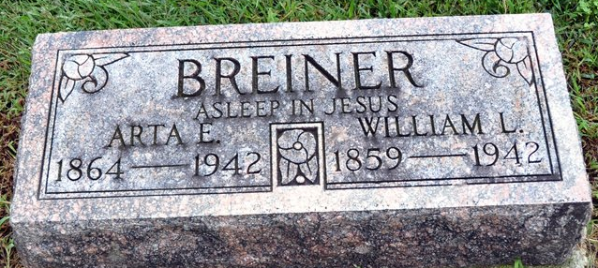
Photo by Deb Curry

MRS. W. L. BREINER CALLED BY DEATH
Craigville Resident Dies After Fall; Her Hip Was Fractured

Mrs. Arta Breiner, 77, wife of William L. Breiner, of Craigville, died at 7:50 a.m. today at the Wells County hospital. Death was due to complications following a fall a week ago in which she fractured a hip.
The decedent was born in Adams County, a daughter of Lawson and Lois Brown Lenhart. She and her husband resided in Craigville the past 25 years, having moved there from a farm in Kirkland Township.
A daughter, Mabel, is deceased. Two brothers, S. P. Lenhart, of Neosho, Mo., and L. C. Lenhart, of Jackson, Mich., survive. Four sisters and two brothers are deceased.
Mrs. Breiner was a member of the Christian Union Church.
The body will be removed from the Jahn Funeral Home Tuesday afternoon to the residence. Funeral service will be held at 2 p.m. Wednesday at the United Brethren Church at Craigville in charge of Rev. Charles Moore. Burial will be in the Zion Cemetery.

Bluffton News Banner, Wells County, Indiana
July 27, 1942

