Wilhelmine (Martin) Yake
August 7, 1849 – June 9, 1939

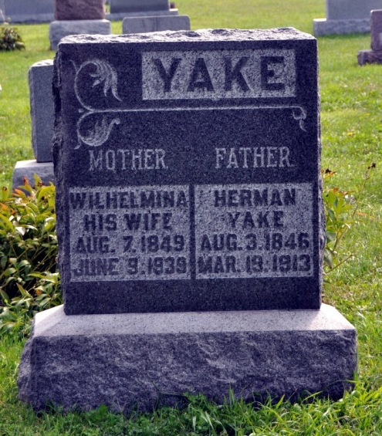
ADAMS COUNTY RESIDENT DIES
Mrs. Herman Yake Dies Early This Morning of Paralysis
Mrs. Herman Yake, 89, for 43 years a resident of Adams County, died at 12:30 o'clock this morning at the home of a son, Lewis Yake, two miles south of Peterson. Death was caused by paralysis after a week's illness.
The deceased was born in Germany August 7, 1849, the daughter of Fred and Anna Weist-Martin. Her husband died in 1914. She was a member of the St. Luke's Reformed Church in Kirkland Township.
Surviving are the following children: Mrs. Edward J. Hessert, of Fort Wayne; Mrs. Cenia Cain, of Columbus, Ohio; Mrs. Wilmer Worthman, Craigville rural route; William Yake, of Sturgis, Michigan, Gust, Lewis, and Henry Yake, all of Decatur Rural Route 2. Thirty-one grandchildren and nine great grand-children also survive. One daughter and one son are deceased. Mrs. Yake was the last surviving member of her family, three brothers and three sisters preceding her in death.
Funeral services will be held at the church Sunday afternoon at 2 o'clock; Rev. H. H. Meckstroth officiating. Burial will be in the church cemetery. The body will be removed to the Lewis Yake residence this evening from the Jahn Funeral Home of Bluffton.
Decatur Daily Democrat, Adams County, IN; June 9, 1939
*****
WHILMENIA YAKE ANSWERS SUMMONS
DEATH OCCURS AT HOME OF SON IN ADAMS COUNTY; FUNERAL SUNDAY
Mrs. Whilmenia Yake, 89, widow of Herman Yake, died at 12:30 a.m. today at the home of a son, Lewis Yake, one mile east of the Kirkland High School. She has been suffering from paralysis for the past week.
Born in Germany, August 7, 1823, she was a daughter of Fred and Anna Weist Martin. Her husband died in 1897. She had been a resident of Adams County for 53 years.
Survivors include three daughters, Mrs. Edward J. Hessert, of Fort Wayne, Mrs. Venia Cain, of Columbus, O., and Mrs. Wilbur Worthman, of Craigville Route; four sons, Gust Yake, Lewis Yake and Henry Yake, near Decatur and William Yake, of Sturgis, Mich.; 31 grandchildren and nine great grandchildren. One daughter, one son, three brothers and three sisters are deceased.
The body will be at the home of the son until time for funeral services which will be conducted at 2 p.m. Sunday at the St. Luke Evangelical and Reformed church, of which she was a member, with Rev. H. H. Meckstroth in charge. Burial will be in the church cemetery.
Evening News-Banner, Bluffton, Wells County, IN; June 9, 1906

